German Home Learning w/c 4th January 2021
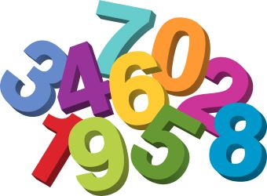
Guten Tag Klasse! Wie gehts?

This week for your German lesson, let’s practise our numbers again. Can you remember how to count to 30 in German? If you need some help, have a look at one of these websites:
https://www.youtube.com/watch?v=N_Lfwc2Fu40
https://www.youtube.com/watch?v=KO9DAnw39do
https://www.twinkl.co.uk/resource/T-T-032-German-number-posters

Have a go at completing as many of these activities as you can:

- Can you video yourself counting the numbers 0-30 in German? Counting forwards and backwards? You could send me the recording to watch!

- Can you teach someone in your family to count from 1 to 10 in German?

- Can you research any higher numbers in German? 30-100? What language patterns do you notice? Can you a write down the numbers?

- Watch this German cartoon video – you’ll learn lots of new words as well as being able to practise numbers: https://www.youtube.com/watch?v=gfu0SwwqDt8

- Can you learn how to count 1-20 in any other languages?

A little extra:
Fun Facts – do you know how to read German number plates on vehicles? Have a look at the link below to discover how: https://ukgermanconnection.org/kids/find-out-en/german-numberplates

