Geography Task for the week of 22/6/20

Draw a Map of an Imaginary Island
Use map elements, like symbols and a key, to show different features of the island and its people. Here are examples you can use as inspiration.

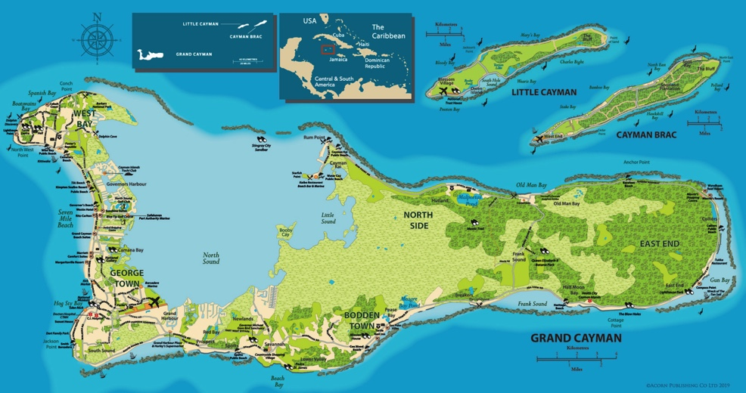
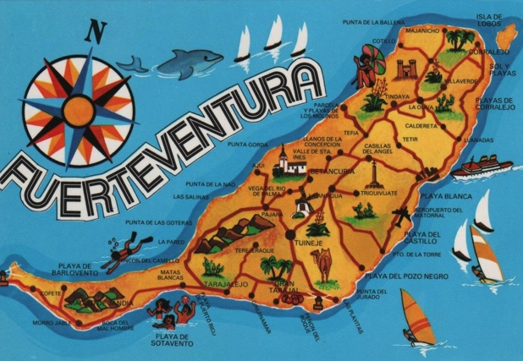
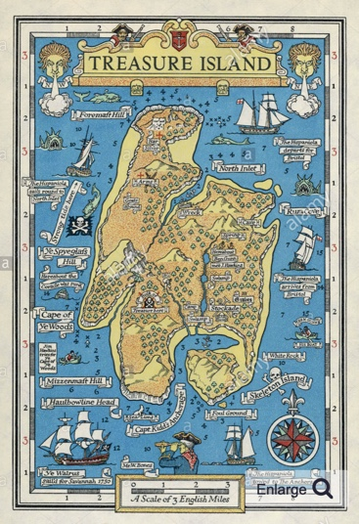
Maps of Islands

Extra Challenge (link to last week’s learning): Draw a grid over the top of your map and note down 4 or 6-figure grid references for features on your island.

