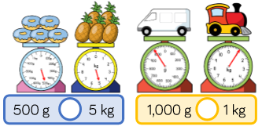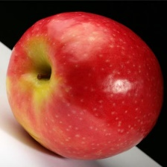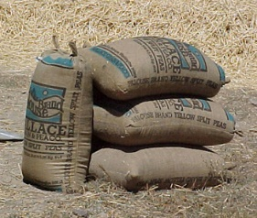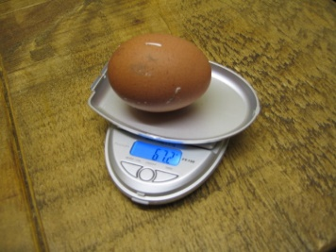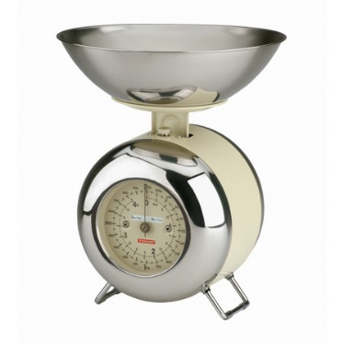

13000g = _____kg

4000g= _____kg

19000g = _____kg

22000g= _____kg

3g= _____kg

8g= _____kg

10000g = _____kg

7000g= _____kg

9000g = _____kg

12000g= _____kg

5000g= _____kg

17g= _____kg

**Challenge- Have a go if you’re super confident!**

**Compare the weights using <,> or =.**

***Hint: You might need to convert first!***

3kg = _____g

8kg= _____g

19kg = _____g

14kg= _____g

5kg= _____g

170kg= _____g

Converting Kilograms to Grams

Converting Grams to Kilograms