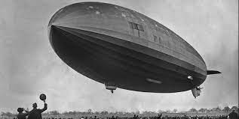

Personification

____________________________________________________________________________________________________________________________________________________________________________________________

Metaphor

____________________________________________________________________________________________________________________________________________________________________________________________

Colons used to add detail

____________________________________________________________________________________________________________________________________________________________________________________________

Short sentences to build tension

____________________________________________________________________________________________________________________________________________________________________________________________