Monday 18th January 2021
To change singular nouns to plural nouns
Change these nouns from singular to plural following the correct spelling rules.
Add s – most words follow this rule.
Add es – if a word ends in a hissing, shushing, buzzing sound.
Change the y to an i and add es – if the word ends in a y
Singular noun | Plural Noun
e.g. book | books
bag
box
baby
stitch
fairy
church
pillow
coat
fox
wish
puppy

Now write some sentences using the plural nouns you have made.
e.g. I read lots of books over the weekend.
_____________________________________________________________________________________________________________________________________________________________________________________________________________________________________________________________________________________________________________________________________________________________________________________________________________________________

Tuesday 19th January 2021
To retell the story of The Storm Whale
You can write in your book or use this sheet with sentence starters to help you.
Noi lived with __________________________________________________
_____________________________________________________________
Every day, _____________________________________________________
_____________________________________________________________
One night, a great storm raged around Noi’s house.
In the morning, _________________________________________________
______________________________________________________________
All of a sudden, Noi spotted something in the distance.
It was a ________________________________________________________
Noi knew that it wasn’t good for a whale to be out of water so he decided to ________
_________________________________________________________________
Noi made the whale feel at home by ______________________________________
_________________________________________________________________
Noi was worried his dad would be ________________________________________
_________________________________________________________________
When Noi’s dad saw the whale, he wasn’t angry but he told Noi __________________
_________________________________________________________________
Noi and his dad _____________________________________________________
_________________________________________________________________
Noi hoped _________________________________________________________
Wednesday 20th January 2021
To complete a role on the wall for Noi

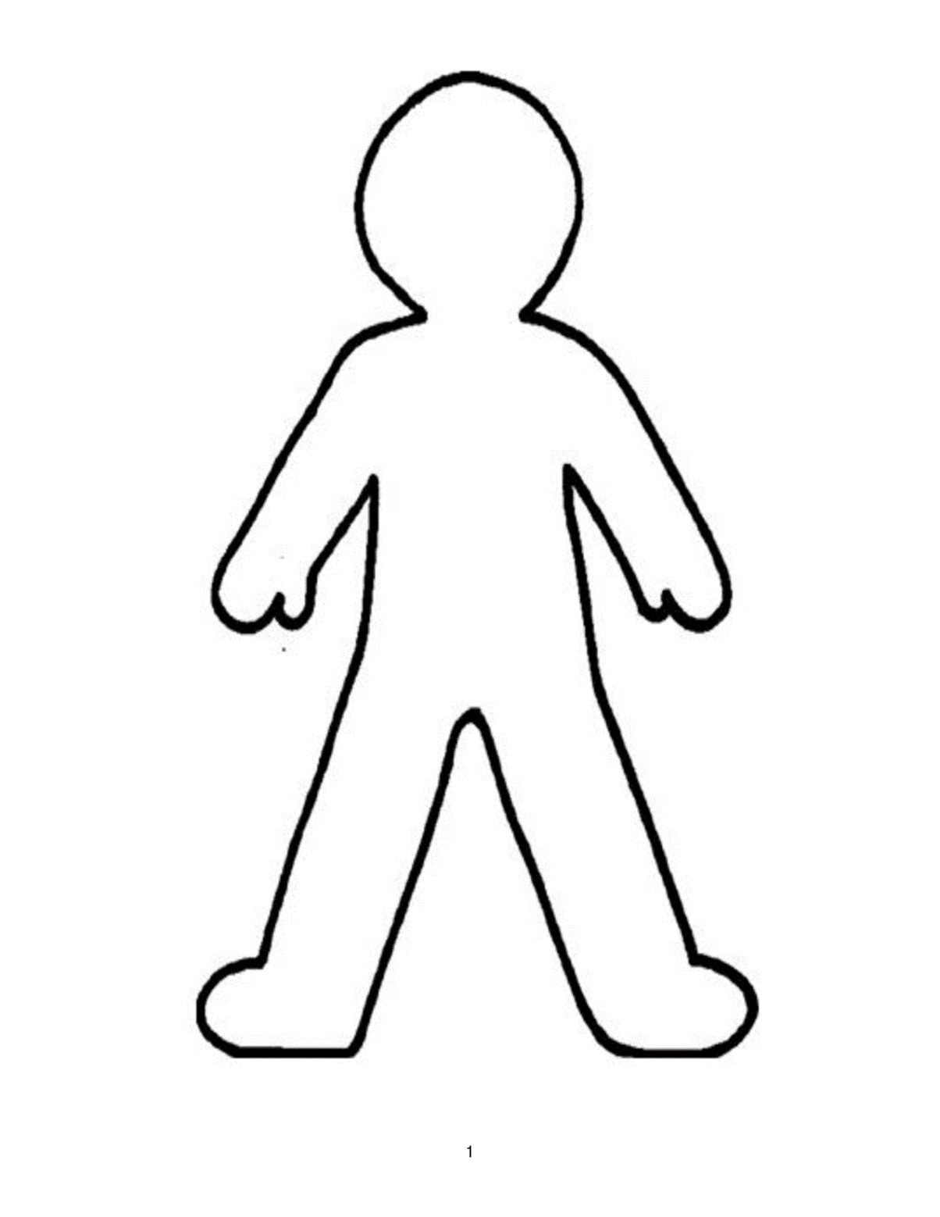

Thursday 21st January 2021
To write predictions about our new story ‘Grandma Bird’
I can see
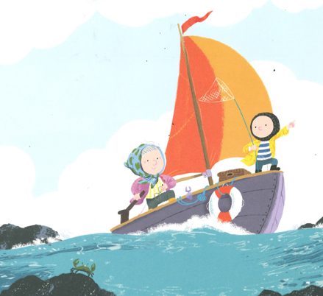
I’m wondering
I think

Friday 22nd January 2021
To write about a characters thoughts and feelings
We will draw Noi together during the live session.
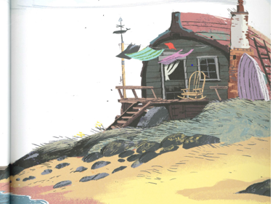

I’ve just arrived at Grandma’s house.
I feel _____________________ because __________________________
___________________________________________________________
I feel _____________________ so _______________________________
___________________________________________________________
I think _____________________ because __________________________
___________________________________________________________
I think _______________________ so_____________________________
___________________________________________________________

