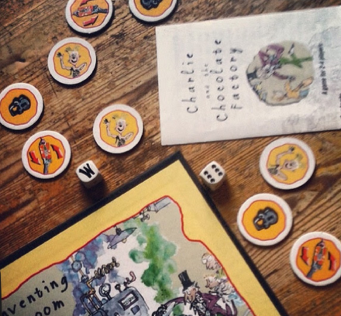
Have a close look at the Charlie and the Chocolate Factory Board Game (left). What do you notice about it?
- How do you think you play?
- How might you win?
- I wonder what the rules might be?

YOUR CHALLENGE…
Create your own game inspired by what you have read so far in Charlie and the Chocolate Factory. It can be a board game if you like but it doesn’t have to be!
Remember to include instructions for your game so that other people can play it!

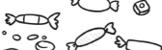

Think about: how many players your game will need, what the game will look like, how do you win, what are the rules, what will you use for counters (if you need them)?

My Game Instructions
You will need:

Players:

_____________________________________________________________________________________________________________________________________________________________________________________________________________________________________________________________________________________________________________________________________________________________________________________________________________________________________________________________________________________________________________________________________________________________________________________________________________________________________________________________________________________________________________________________________________________________________________________________________________________________________________________________________________________________________________________________________________________________________________________________________________________________________________________________________________________________________________________________________________________________________________________________________________________

