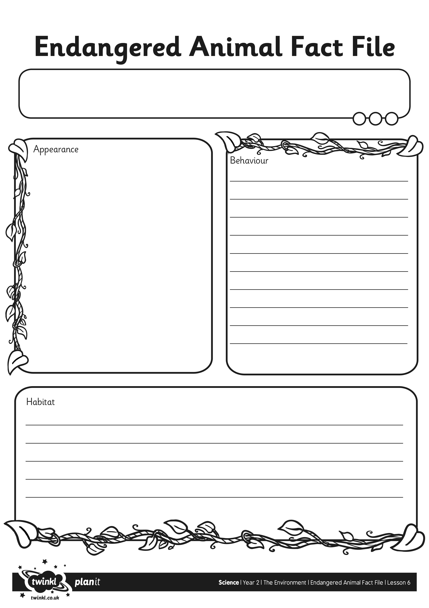
I can ask and answer questions about endangered animals.

