Dougal’s Deep Sea Diary Planning 15th June 2020 – 27th June
You will find planning for the next two weeks as well as resource sheets in this document. Please view the photo story and youtube video reading.
Monday 15th  LO: To make predictions about a text. | Look at the front cover of the text before reading.  Use the sentence starters to make predictions about the text.  I can see…. I think that …. I’m wondering…  (We usually write 3 sentences for each in class).
Tuesday 16th  LO: To use expanded noun phrases and verbs and adverbs. | Look at the under water scene where Dougal first goes diving.  Describe the sea creatures you can see using expanded noun phrases, verbs and adverbs.  e.g. The small orange fish darted quickly around the seaweed.
Wednesday 17th  LO: To write a diver’s log book.  SC: I can use verbs and adverbs. | Read the text up to Wednesday… I felt tired and a little glum.  Use the text to list creatures Dougal met from Saturday to Wednesday. Encourage children to focus on large sea creatures rather than fish: Sharks, crabs, turtle, octopus, whales, dolphins  Create a diver’s notebook of creatures met so far from Dougal’s point of view. Encourage the use of language from the text to add detail to the notebook. Focus on using conjunctions to extend sentences and the detail within sentences.  A Diver’s Notebook  Sharks I have only seen them when I have been in my capsule. They always look hungry and they have big sharp teeth. They glide through the water and swish their strong fins from side to side.
Thursday 18th  LO: To use contractions | Complete the contractions table and use the contracted forms in sentences.  I am I’m  We are we’re
Friday 19th  LO: To create a role on the wall | Think about everything you know about Dougal so far.  Create a roll on the wall.  Outside write all the facts you know (He is a man, he likes diving).  Inside write down his personal qualities (He is adventurous)

Monday 22nd  SC: I can describe a setting. | Look at Atlantis – what can you see? Make a list of the things you can see, hear and feel.  Now write sentences as if you are there.  I can see… I can hear…. I can feel… I really like…. I wonder …
Tuesday 23rd  SC: I can write a letter. | At the end of the story Dougal decides to not go back to his day job.  Imagine being Dougal.  Write a letter to a friend explaining why you decided to stay.
Wednesday 24th  SC; I can write a poem | Write a poem with a beach or diving theme. It can be a shape poem, verse poem or acrostic poem. Your poem doesn’t need to rhyme!  Draw picture and decorate your page.
Thursday 25th  SC: I can research using book and the internet. | Reading/research day – pick a sea creature to research (not a seahorse as this will be our next topic)– find out facts and make a fact file or poster or model of your chosen creature.
Friday 26th  SC: I can describe a seahorse. | Watch the short animated film clip of seahorses moving  https://www.youtube.com/watch?v=BdQIykGWpG4  Fill in the table – what they look like section.  Descibe how the seahorse looks using noun phrases (small fins)  Now think about HOW they move. Watch the clip again and note down VERBS to describe their movement e.g. rock, glide, float, dive, slide, wrap around, hang onto, grab, spin.  Finally write descriptive sentences.  e.g. The seahorse is swimming in the water and it is diving down to the bottom of the seabed. It likes wrapping its body around the plants on the seabed. I can see it is rocking its body backwards and forwards.

Monday 15th June 2020
SC: I can make predictions about our new text, “Dougal’s Deep Sea Diary”
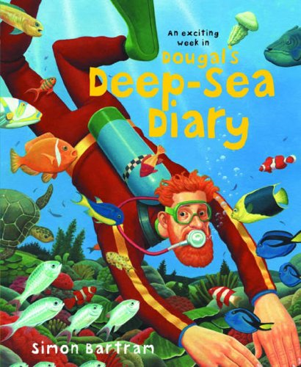
I am wondering…
I can see…
I think that…

Tuesday 16th June 2020
SC: I can use verbs and adverbs to describe sea creatures.
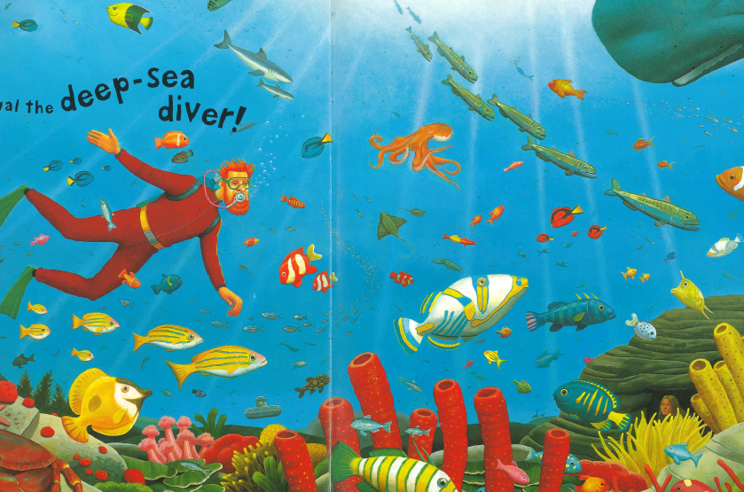

Wednesday 17th June 2020
SC: I can write a diver’s log book in first person.
Pick a sea creature, describe how it looks, what it is doing in the water and your opinion of them.

Sharks
_____________________________________________________
_____________________________________________________
_____________________________________________________

Dolphins
_____________________________________________________
_____________________________________________________
_____________________________________________________

Crabs
_____________________________________________________
_____________________________________________________
_____________________________________________________

Thursday 18th June 2020
SC: I can use contractions.
I am | do not
could not | I will
you are | we are
is not | have not
she is | he is

Friday 19th June 2020
SC: I can complete a role on the wall about the character of Dougal

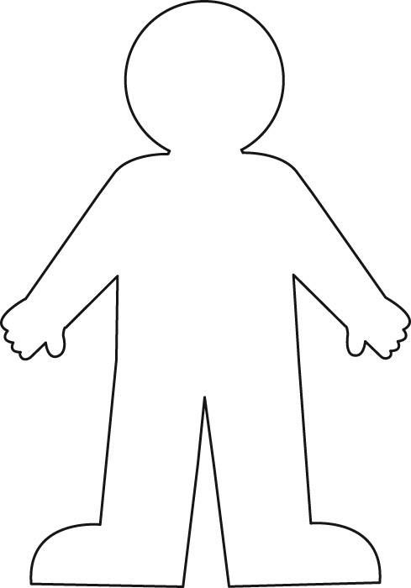

Monday 22nd June 2020
SC: I can describe a setting – Atlantis

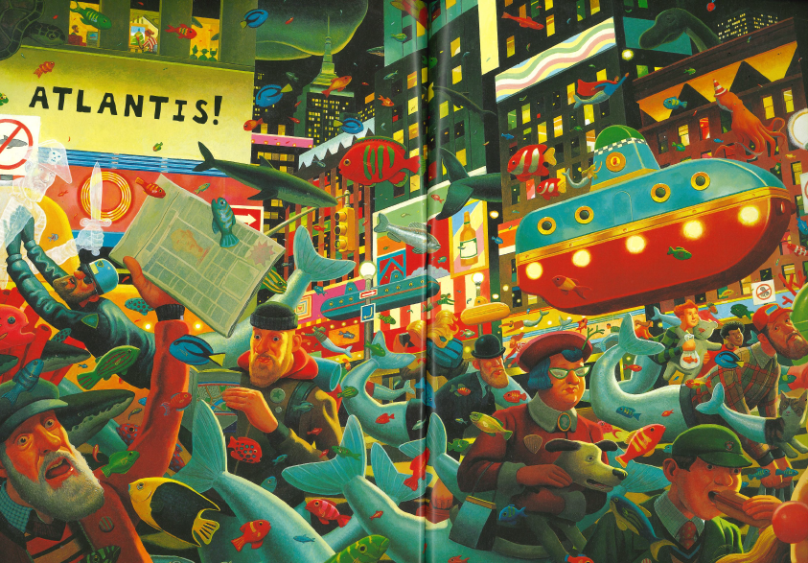

Tuesday 23rd June 2020
SC: I can write a letter in first person.

Wednesday 24th June 2020
SC: I can write a poem about the beach/ocean.

Thursday 25th June 2020
SC: I can research a sea creature and record my favourite facts.

Friday 27th June 2020
SC: I can describe a seahorse.
What it looks like | How it moves

