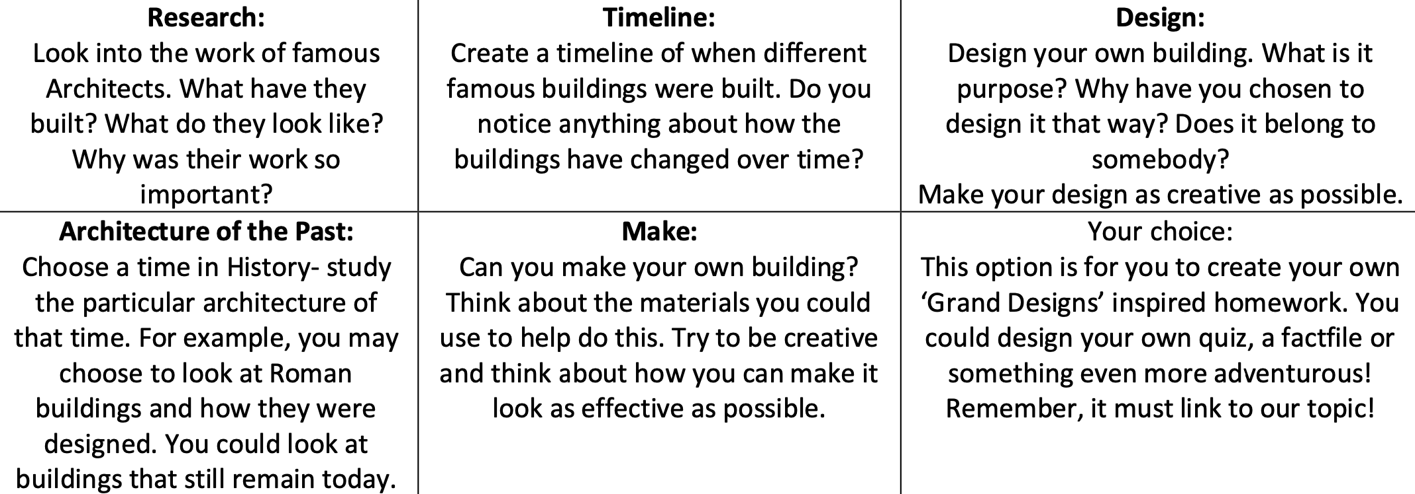
DESIGN AND TECHNOLOGY – GRAND DESIGNS

THE FOCUS OF THIS D& T PROJECT IS TO EXPLORE AND RESEARCH SOME ARCHITECTS – FIND OUT WHAT THEY HAVE DESIGNED; WHEN THEY WERE AROUND; WHAT’S INTERESTING/UNUSUAL ABOUT THEIR DESIGNS? DISPLAY YOUR WORK IN ANY WAY YOU WOULD LIKE – EXAMPLES WILL BE DISPLAYED ON THE ART WEB PAGE FOR THE SCHOOL.

BEGIN AT RESEARCH; THEN TIMELINE; THEN DESIGN; THEN ARCHITECTURE OF THE PAST; THEN MAKE; THEN CHOOSE TO CREATE YOUR OWN PIECE OF WORK BUT LINKED TO OUR MAYA TOPIC (WHAT WAS THEIR ARCHITECTURE LIKE?)

