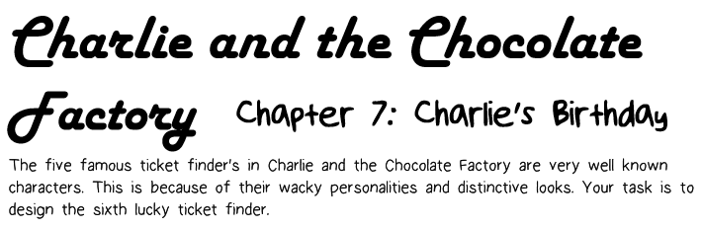

So far, the lucky Golden Ticket characters are known for their wacky, interesting personalities and their distinctive looks. Your task is to design a new lucky ticket finder.

