DON’T COMPLETE THE IRON AGE COLUMN – WE WILL LOOK AT THAT IN A FEW WEEK’S TIME!
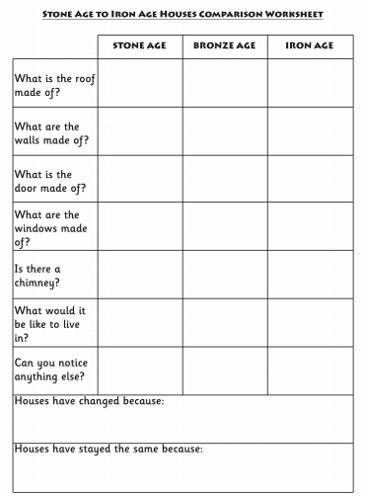
KEEP THIS SOMEWHERE SAFE – YOU WILL NEED IT IN A FEW WEEK’S TIME!

