Comparing cars
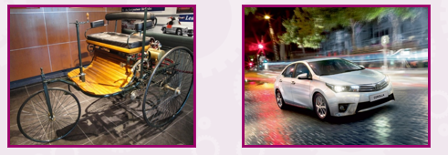
Similarities | Differences

I think the Benz car is good because
A problem with the Benz car is
I think the modern car is good because
A problem with the modern car is

