Commas vs Ambiguity
Insert commas into the following sentences so that the two sentences have different meanings. Can you recognise how the commas change the sentence meaning?

- We ate chocolate cake and raspberries.
We ate chocolate cake and raspberries.
- She liked Ben who played drums better than Jim.
She liked Ben who played drums better than Jim.
- The old lady collected all sorts of things: silver paper hats felt flowers and buttons.
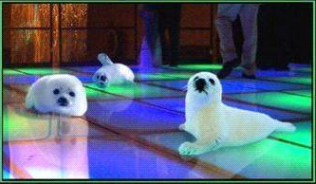
The old lady collected all sorts of things: silver paper hats felt flowers and buttons.
- Let’s eat Grandpa.
Let’s eat Grandpa.
- Stop clubbing baby seals
Stop clubbing baby seals.

- Help a burglar.
Help a burglar.

