[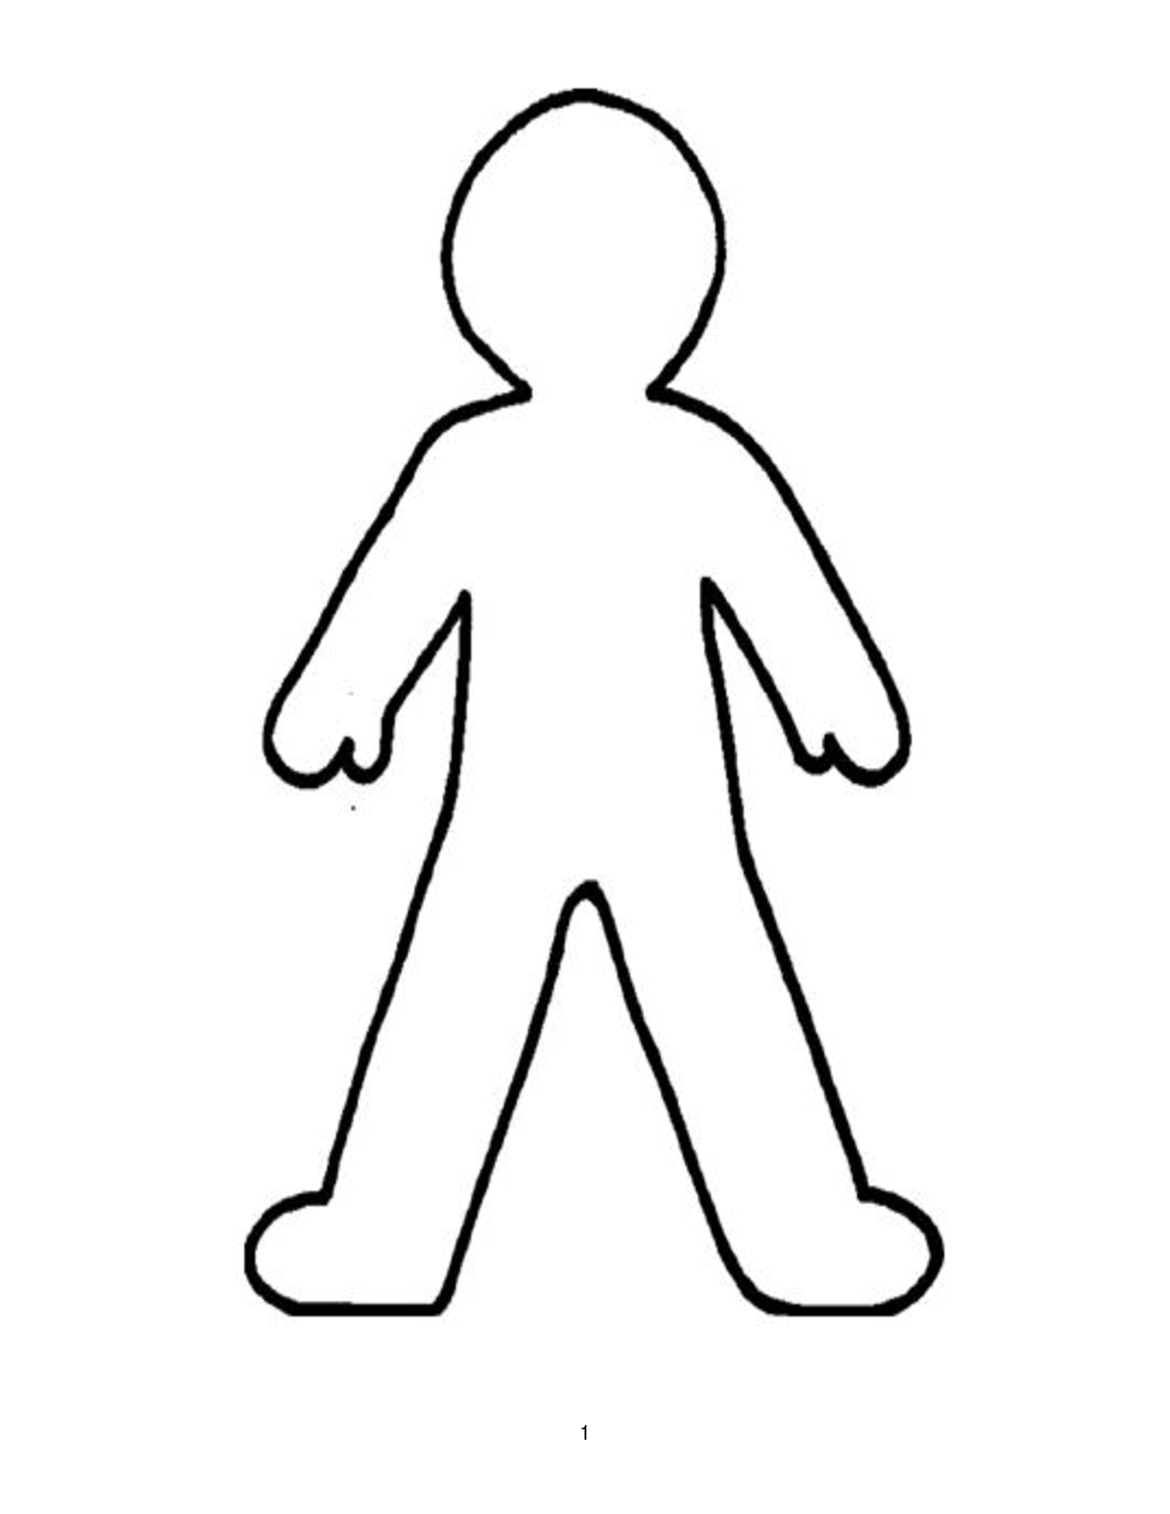](http://www.clipartbest.com/clipart-MKcnnAdTq)

Emotions

Description

**SC: I can describe a main character**