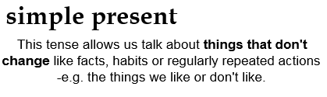
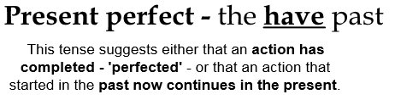
Tense Detective
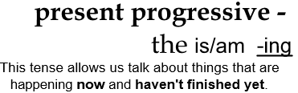
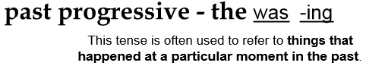
Tick the box in each row to show which tense the sentence is written in.
Sentence | simple past | past  progressive | simple present | present progressive | present perfect | past perfect
I am eating cakes.

She ate cakes.

They were eating cakes.

The children learnt about Romans in history.
The computer works well.

The computer worked well.

I have lost my trainers.

The children are choosing what they want to do.
They added raisins to the muffins.
He was hiding in the laundry basket.
Elaine has wanted to be a police officer for 15 years.
Sam is playing on the computer.

Sam often reads and plays on the computer.
Sam often read and played on the computer.
They have eaten all the cakes and now they feel sick.
I have never been to Legoland.

That was annoying.

