Blood Components Fact Sheet

Blood contains a variety of cell types suspended in a liquid called plasma. Each part blood performs a specific role. The features of each component reflect the role that they carry out.

Red Blood Cells
Red blood cells are the most common blood cells, they travel suspended in the blood plasma. Red blood cells are biconcave, this means that they are shaped like a flat disc with a dimple on each side. Red blood cells look like a Trebor mint or a doughnut with the hole in the middle filled in.

The role of red blood cells is to carry oxygen in the blood. They take up oxygen from the lungs and deliver it to cells in the body’s tissues. Their biconcave shape means that the cell has a large surface area which helps it to absorb oxygen. Furthermore, red blood cells do not contain a nucleus, this creates room inside the cell allowing them to carry more oxygen.

Red blood cells contain a substance called haemoglobin, a red chemical which contains iron. Haemoglobin helps red blood cells absorb oxygen. In the lungs, haemoglobin combines with oxygen to form oxyhaemoglobin. In the body’s tissues, oxyhaemlobin breaks down to haemoglobin, releasing oxygen from the red blood cell. The released oxygen can be taken up by cells.
Red Blood Cells

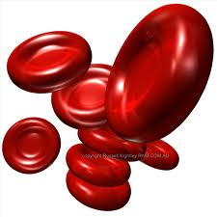

White Blood Cells
White Blood Cells defend the body against infection from microorganisms. There are two different types of white blood cell; each type does a slightly different job. Both types are suspended in the blood plasma.

Phagocytes are the first type of white blood cell. Phagocytes kill microorganisms like bacteria if they get into the blood. Phagocytes have to be very flexible as they kill microorganisms by surrounding and engulfing them. Once inside the phagocyte, the microorganism is digested by powerful enzymes and killed.
White Blood Cells – Phagocyte

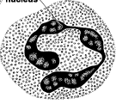

The other group of white blood cells are called Lymphocytes. Lymphocytes produce chemicals called antibodies. Antibodies stick onto foreign microorganisms in the blood, this either kills the microorganisms or causes them to clump together, making it easier for phagocytes to engulf and destroy them. Besides helping to kill microorganisms Lymphocytes also protect the body as they are able to neutralise the harmful poisons or ‘toxins’ produced by microorganisms.
White Blood Cells – Lymphocyte
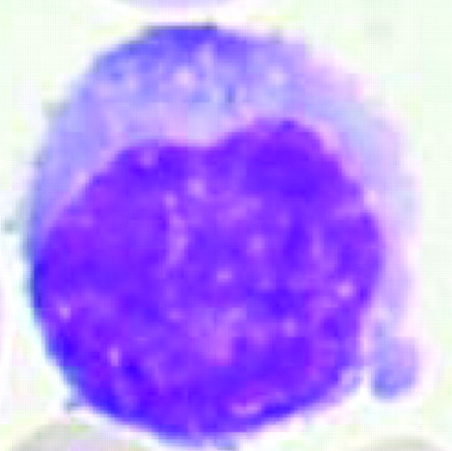

Platelets
Platelets are small fragments of cells, they have no nucleus and are suspended in the blood plasma. Platelets play an important role in helping blood to clot at a wound. When the wall of a blood vessel is damaged platelets seal and clot the wound. This prevents blood cells from being lost from the blood and also stop microorganisms entering the blood through the wound.
Platelets
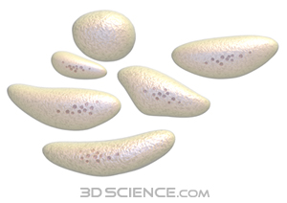

If you did not have any platelets your wounds would never be able to clot and heal.

Plasma
Plasma is a straw coloured liquid. Plasma carries all of the different types of cell contained in the blood. Since the blood plasma is a liquid some substances are carried by being dissolved directly in the blood plasma. For example, Carbon dioxide is produced as a waste product by cells in the body tissues, this carbon dioxide is dissolved in the blood plasma so that it can be transported to the lungs and removed from the body. The sugar glucose is also carried to the body tissues by being dissolved in the blood plasma.

