Art and D&T Planning
The following ideas link to our English work ‘On Sudden Hil’
1 | Make a box habitat.  Choose a habitat and use different materials to make the box look like that habitat.  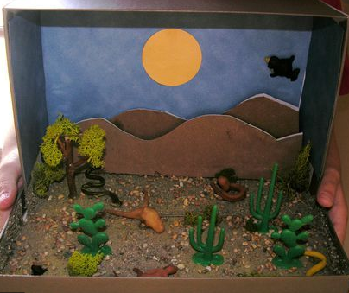
2 | Design and make a toy using a box.  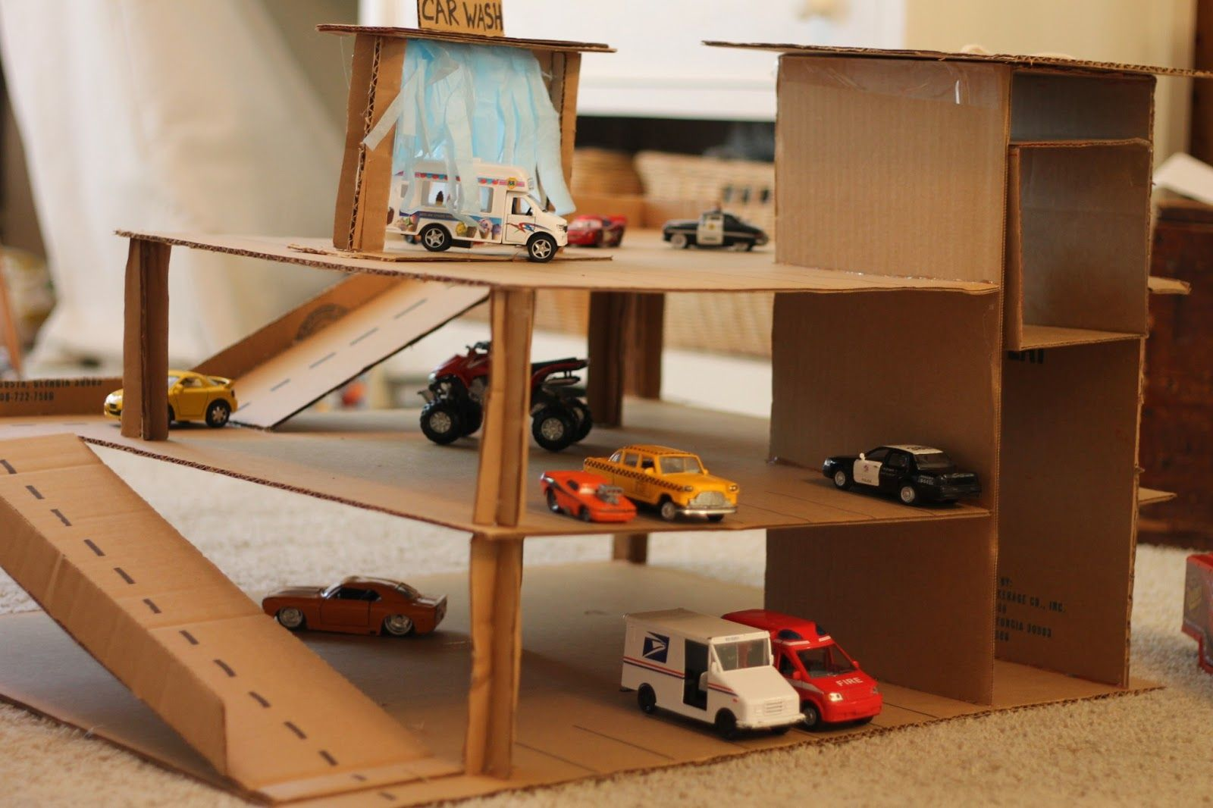
3 | Design and make a moving vehicle using a box.  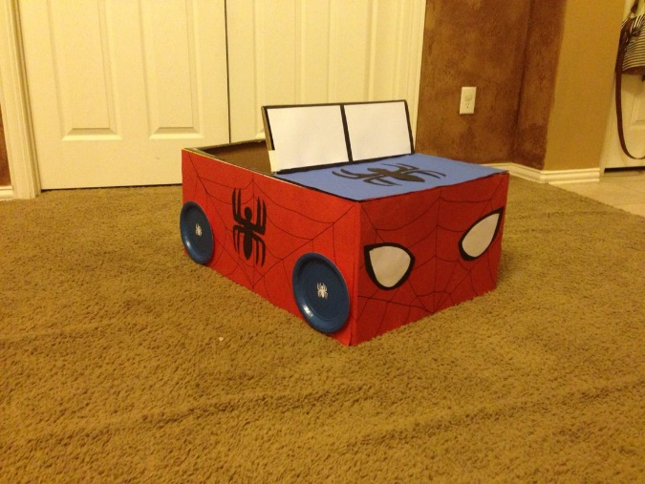
4 | Make a castle or house out of a box.  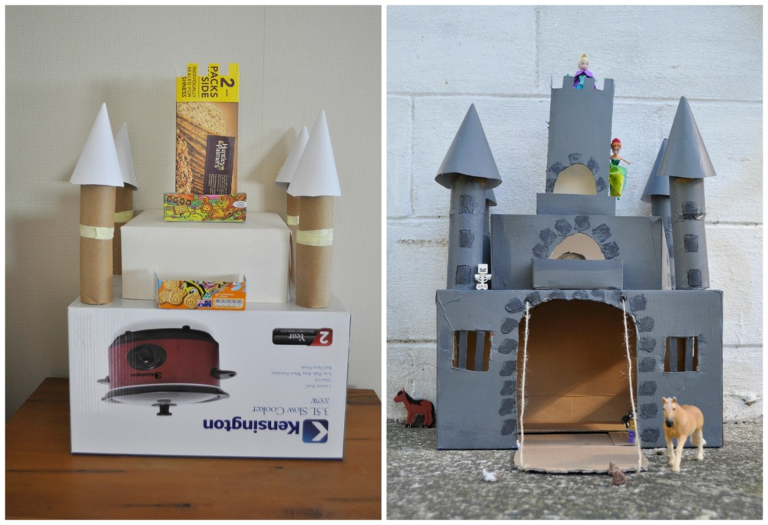

The following ideas are linked to our plants topic.
1  Cont… | Make a 3D vase and flowers.  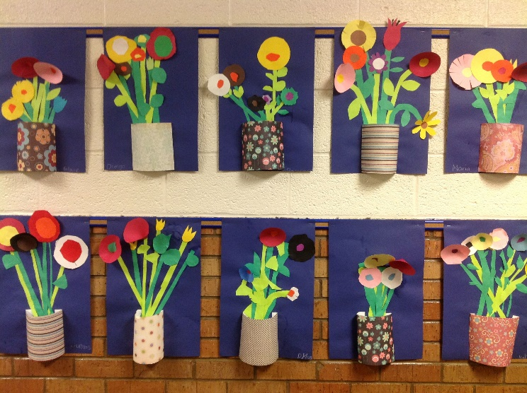
2 | Van Gogh’s sunflowers.  Paint, collage, draw, tissue paper, stencil – sunflower art.  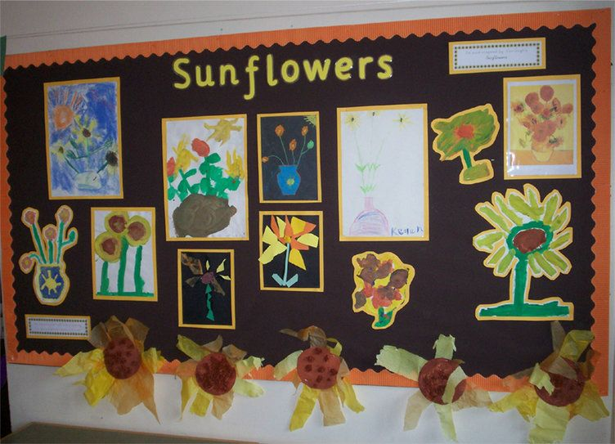
3 | Create a mosaic of different flowers.  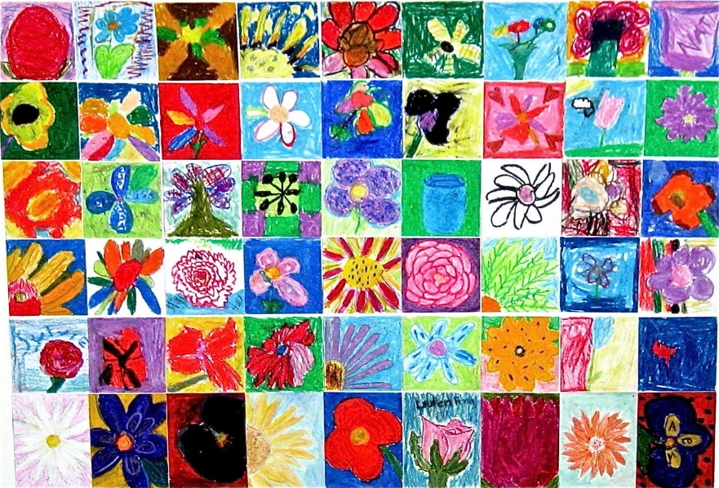
4 | Create a flower garden picture using different materials.  