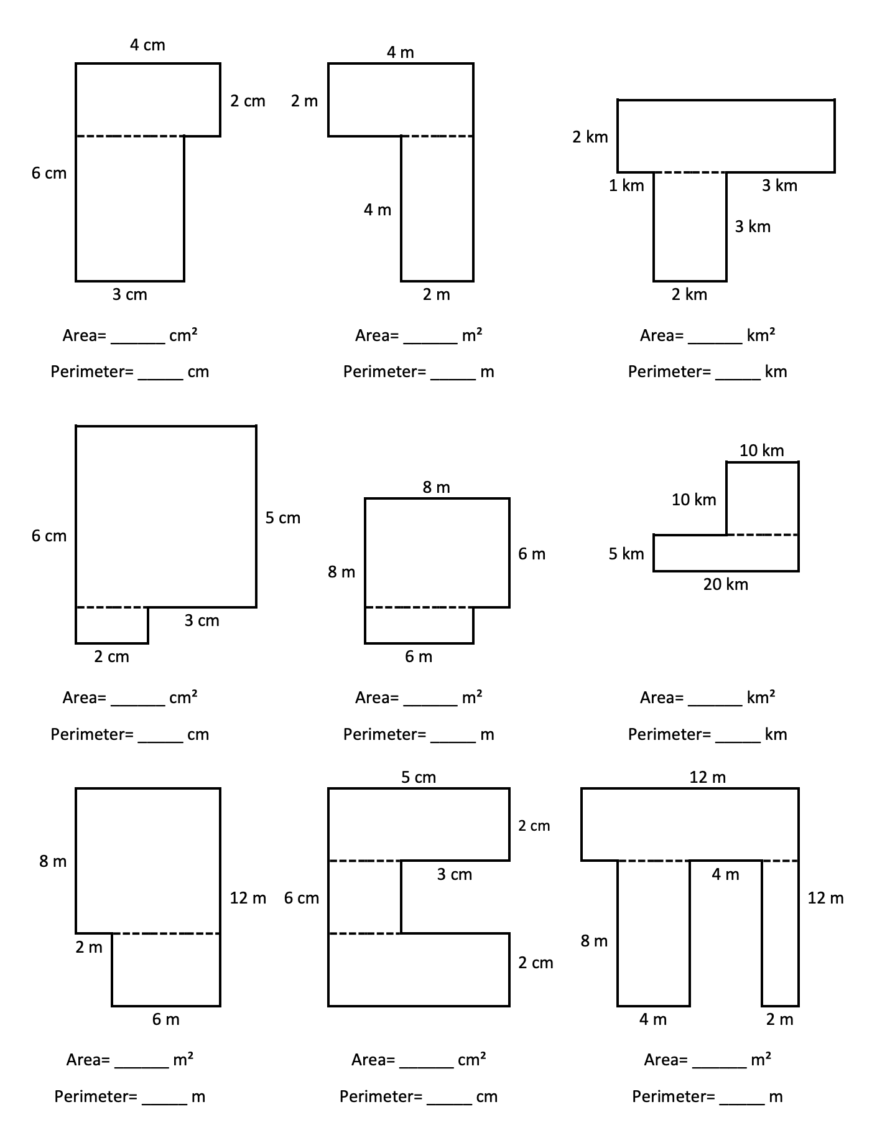

Calculate the area and perimeter for the shapes below:

13/7/20

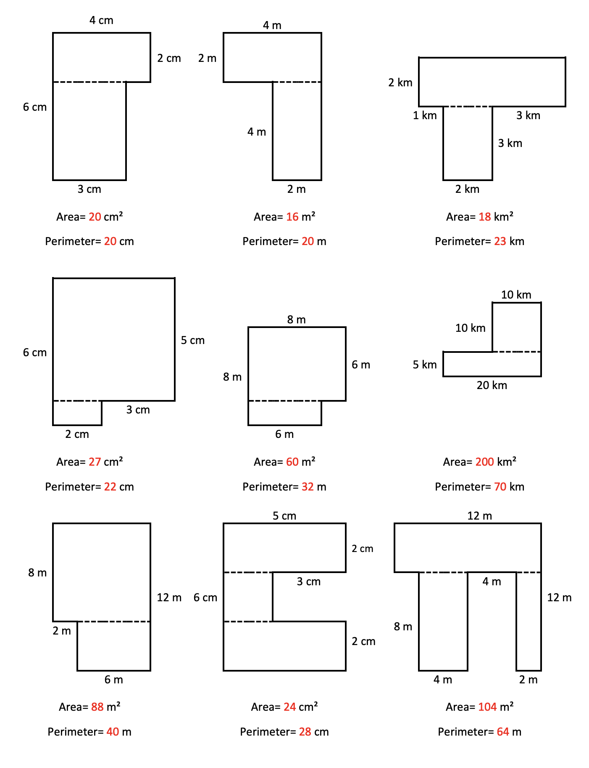

**ANSWERS**