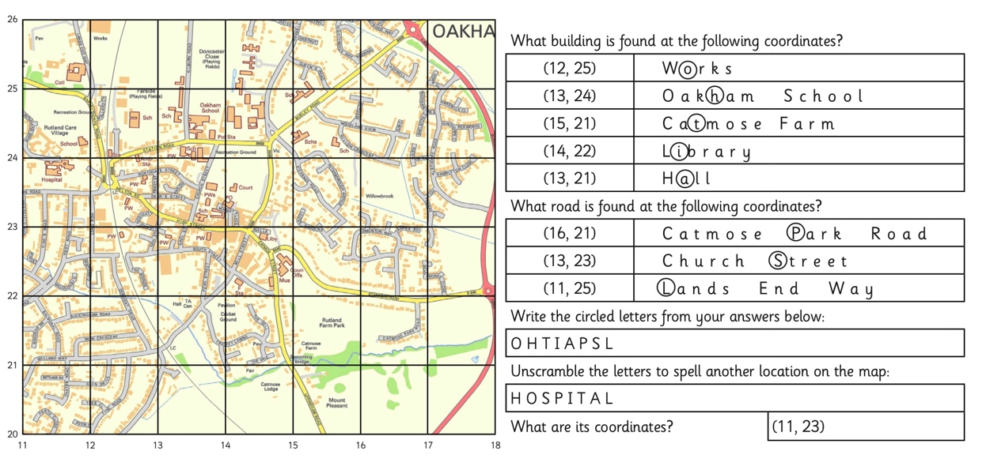
FOUR-FIGURE GRID REFERENCES

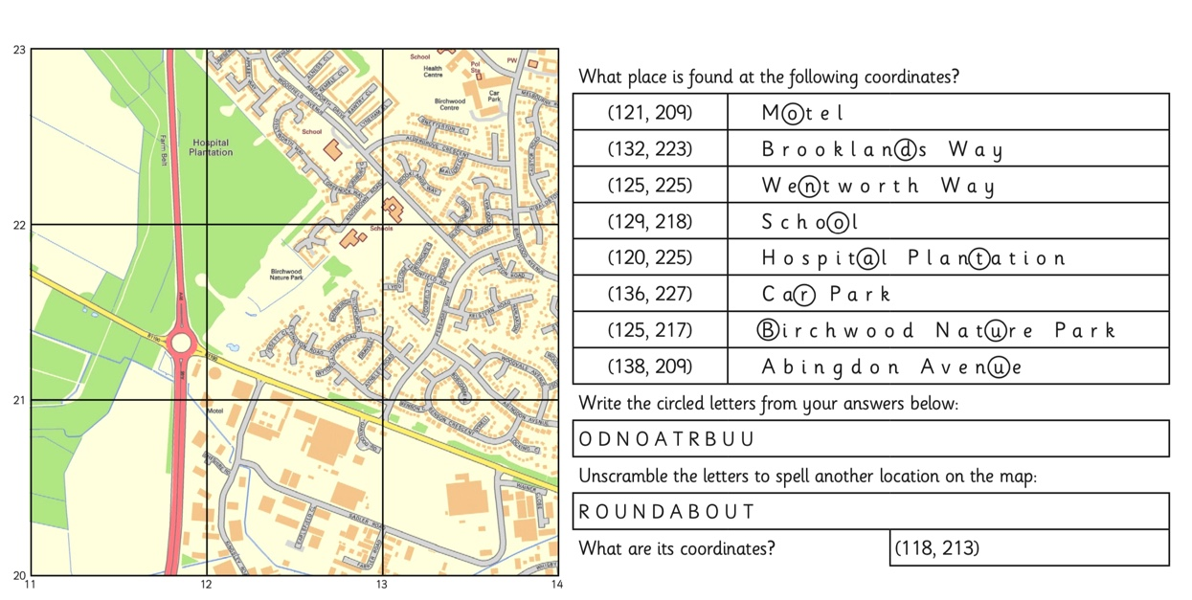
SIX-FIGURE GRID REFERENCES

