Who were the Ancient Maya people? (Home Learning Grid)
It is said that the history of chocolate begins with the Ancient Maya people. Only the rich and noble members of the Maya society drank chocolate.  Research the history of chocolate – choose how to present your findings – then have a go at making a Maya inspired chocolate drink using any of the following recipes:  https://www.mykitchen.co.za/favourites/mayan-hot-chocolate/ | Create an ancient Maya time line –  https://www.ducksters.com/history/maya/maya_civilization_timeline.php - present your time line in your own way  The Maya civilization is divided into three distinct periods. The first is the Preclassic Period (About 2500 BC to AD 250) where the people live in simple houses in family communities that are surrounded by farmland. The second is the Classic Period (About AD 250 to AD 900) where the Maya villages grow into large cities with temples, palaces, and roads. There are now nobles and priests, as well as farmers. The third is the Postclassic Period (900 AD to 1500 AD). | Research the Ancient city of Tikal. What would it have been like in Maya times? What is it like now? Write about some of the similarities and differences. | Where about in the world did the Ancient Maya people live? Use a map to find out. Can you plot the different Maya cities on the map?  (Blank map of North and South America is available on the class web page for you to annotate)
 |  | Research the Maya class structure – Can you find out what life was like for some of these groups of people during Ancient Maya time? | What Maya myth can you find out about?  (see the link on the class web page for Maya myths)  Re-tell the story in your own words.  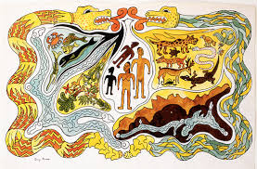
 | Who was the most famous Maya King or Queen? Write a fact file about them. | Find out about the Maya ball game of Pok- a-tok then write a set of instructions explaining how to play it http://mayas.mrdonn.org/ballgames.html | Research the different Maya Gods. Choose at least three and create a fact-file for each of them – include pictures and information in your fact-files.
The Maya people used a base 20 number system. Can you research and write the numbers 1- 20 in Maya numbers? Challenge – Can you go further than 20? Can you write some calculations with answers using the Maya base 20 number system? | Research an area of the Ancient Maya civilisation you find interesting. You could choose home life, clothing, music or religion. Find information about this chosen area and write about what you have learnt. | 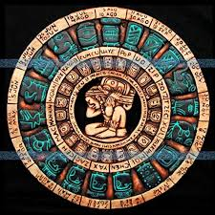  Draw an ancient Maya calendar and explain how it works. | Write about why temples were so important to the ancient Maya civilisation.  