13.1.21
Change the meaning of these words by adding ‘un’ to the beginning. Then draw a picture to match the meaning of the new word. The first one has been done as an example for you.
Root word | Add un | Draw a picture
zip | unzip | 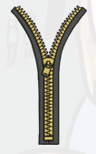
pack
tie
happy
tidy
clean
well
load

