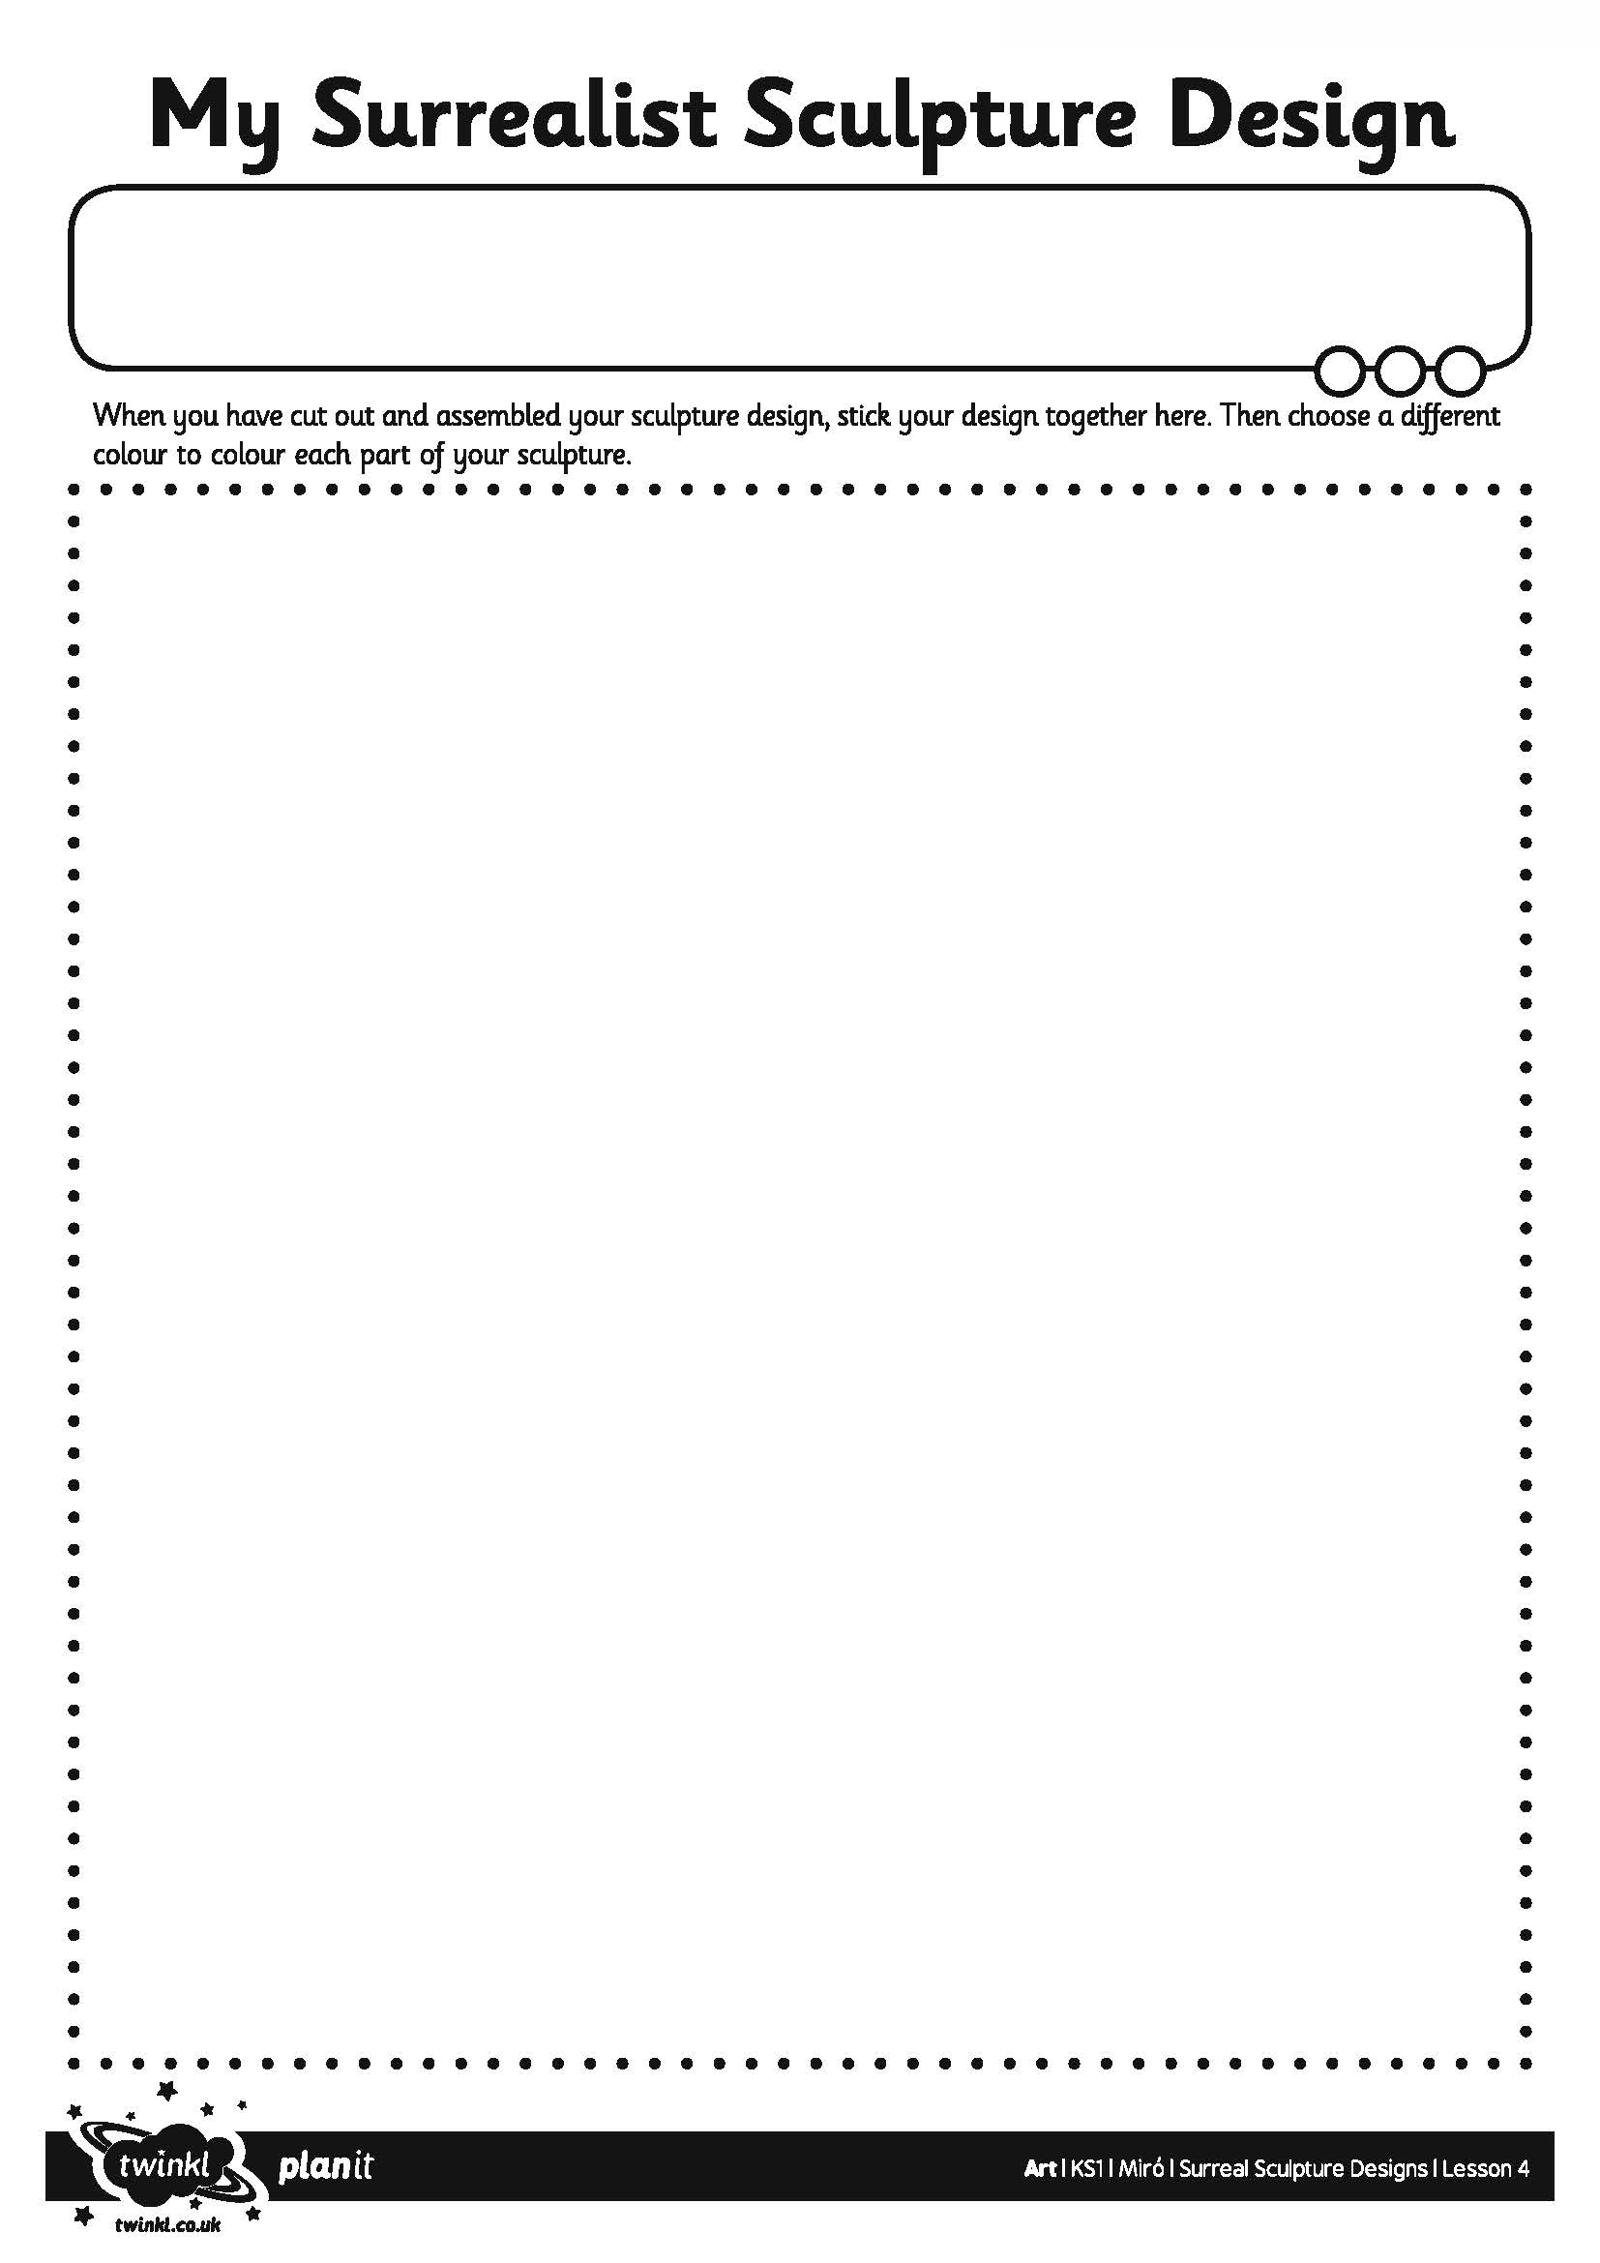
I can design a Surrealist sculpture.
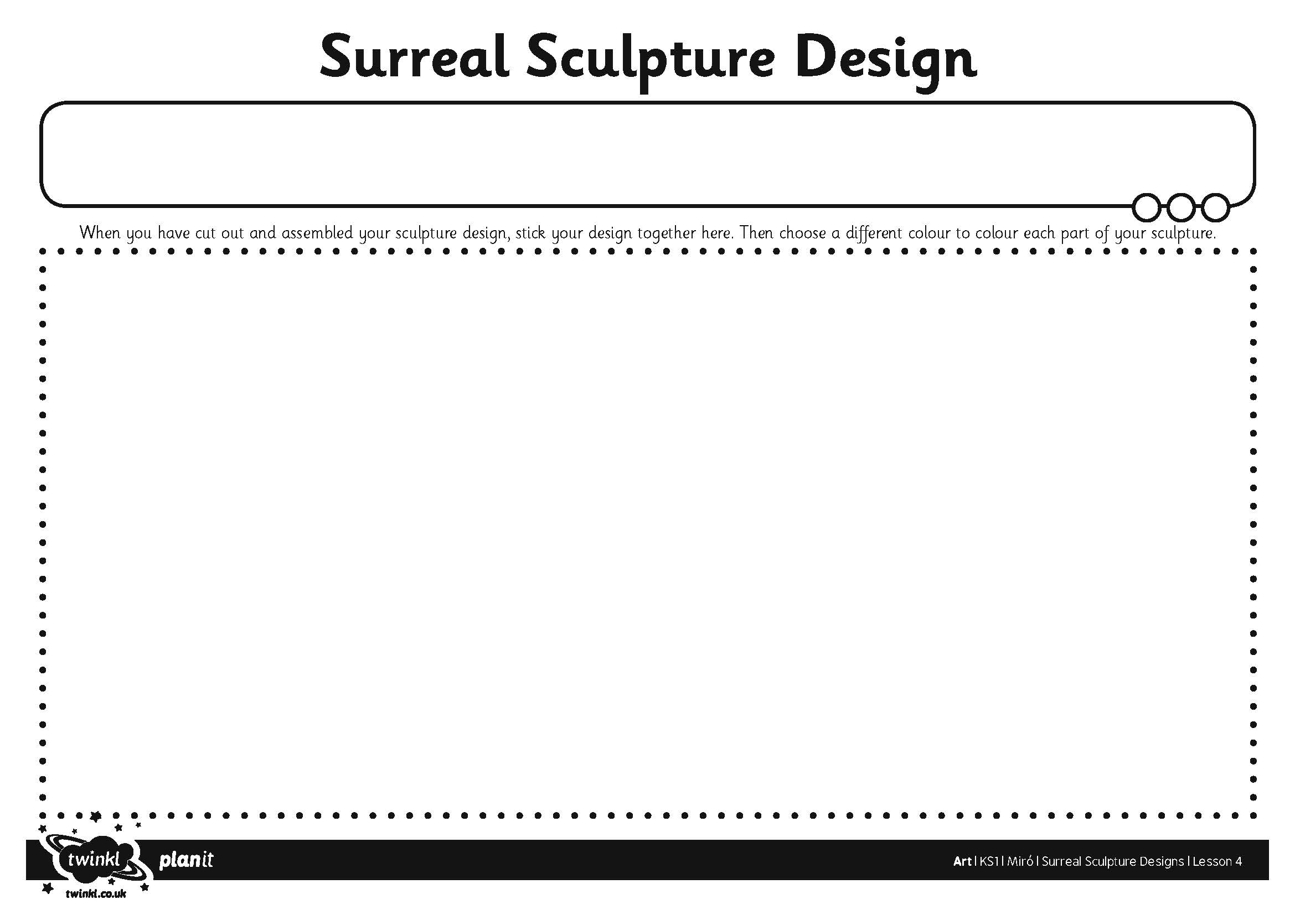
I can design a Surrealist sculpture.

