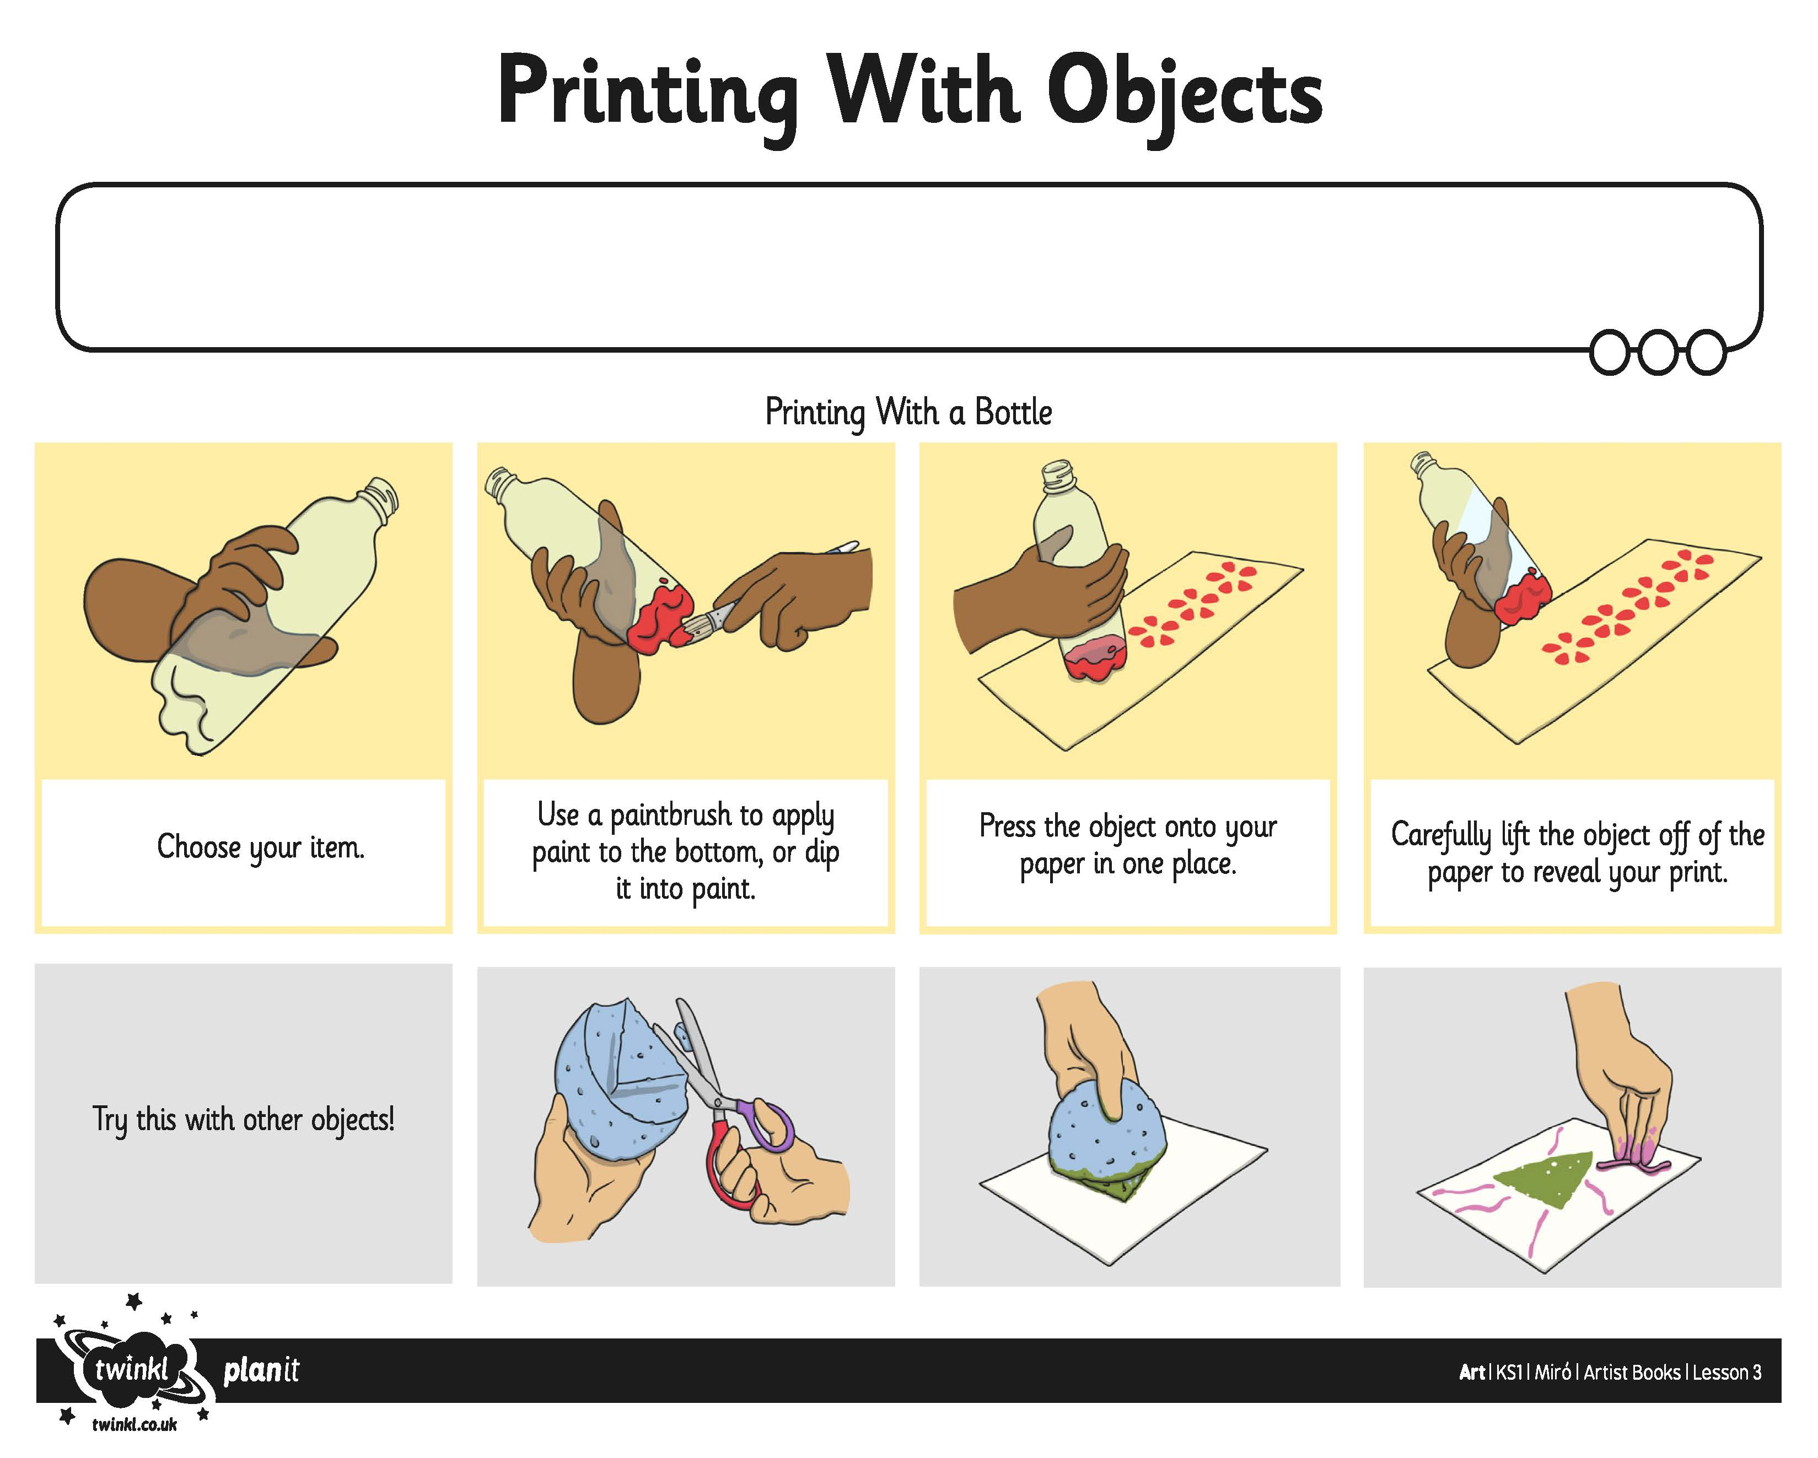
I can make a print by dipping an object into paint and pressing it onto the page.
I can create my own shapes to print with, using string or sponge.
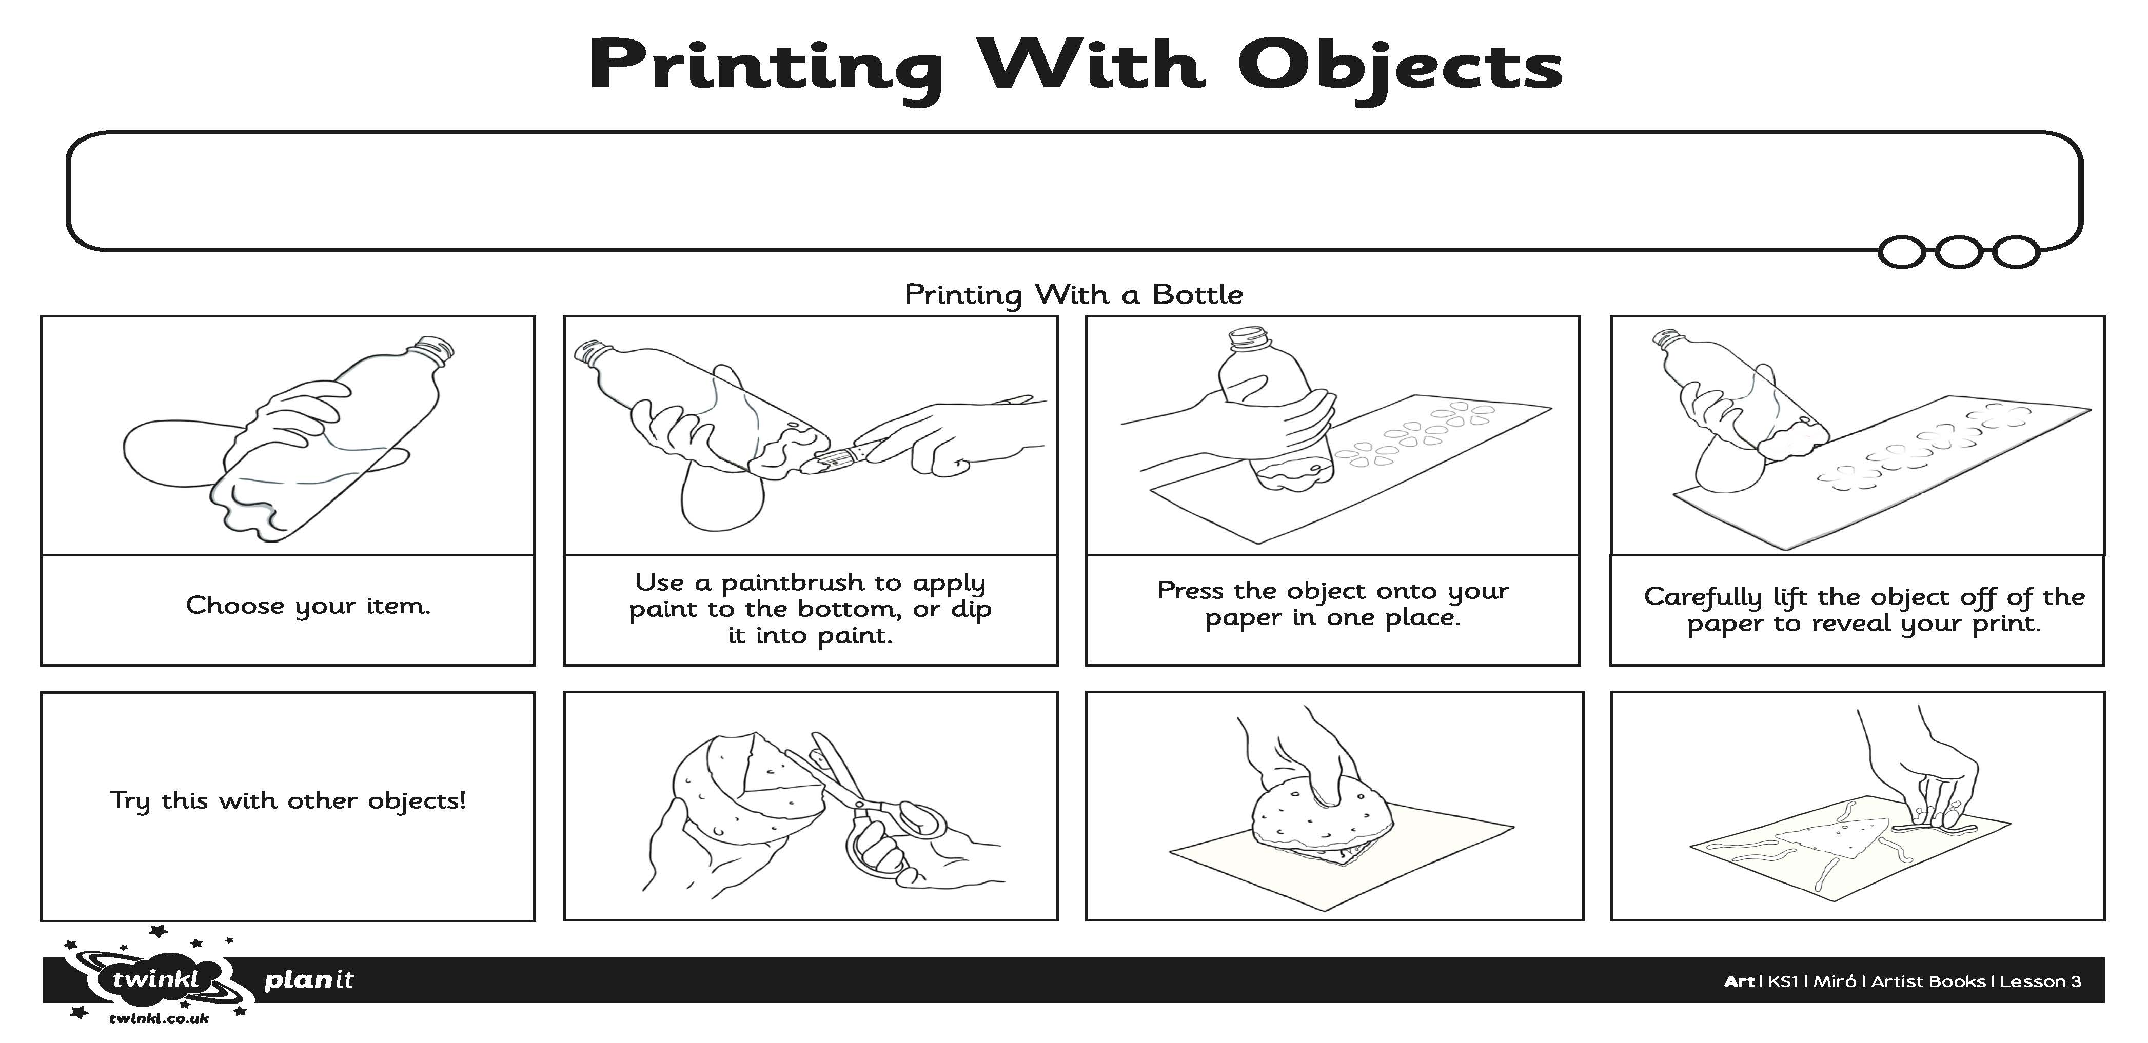
I can make a print by dipping an object into paint and pressing it onto the page.
I can create my own shapes to print with, using string or sponge.

