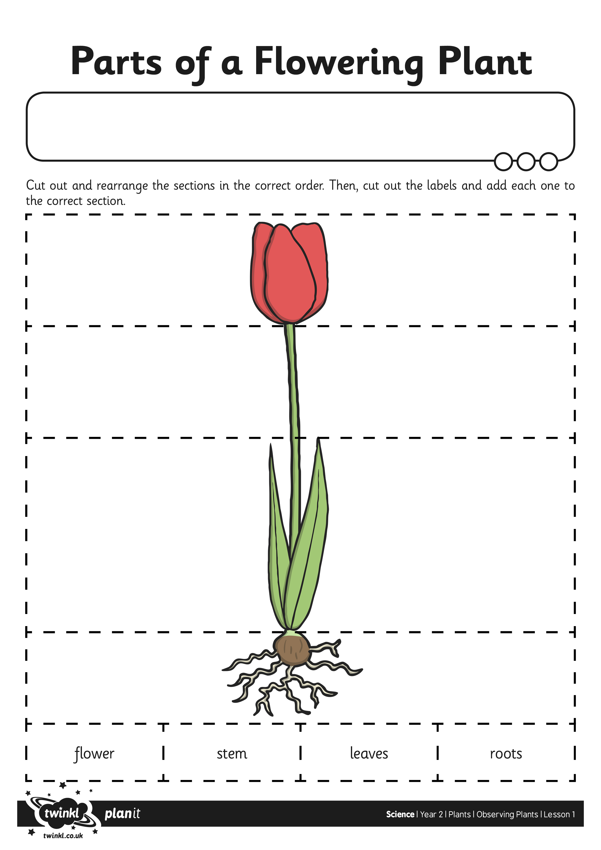
I can look closely at plants and trees and record what I see.

