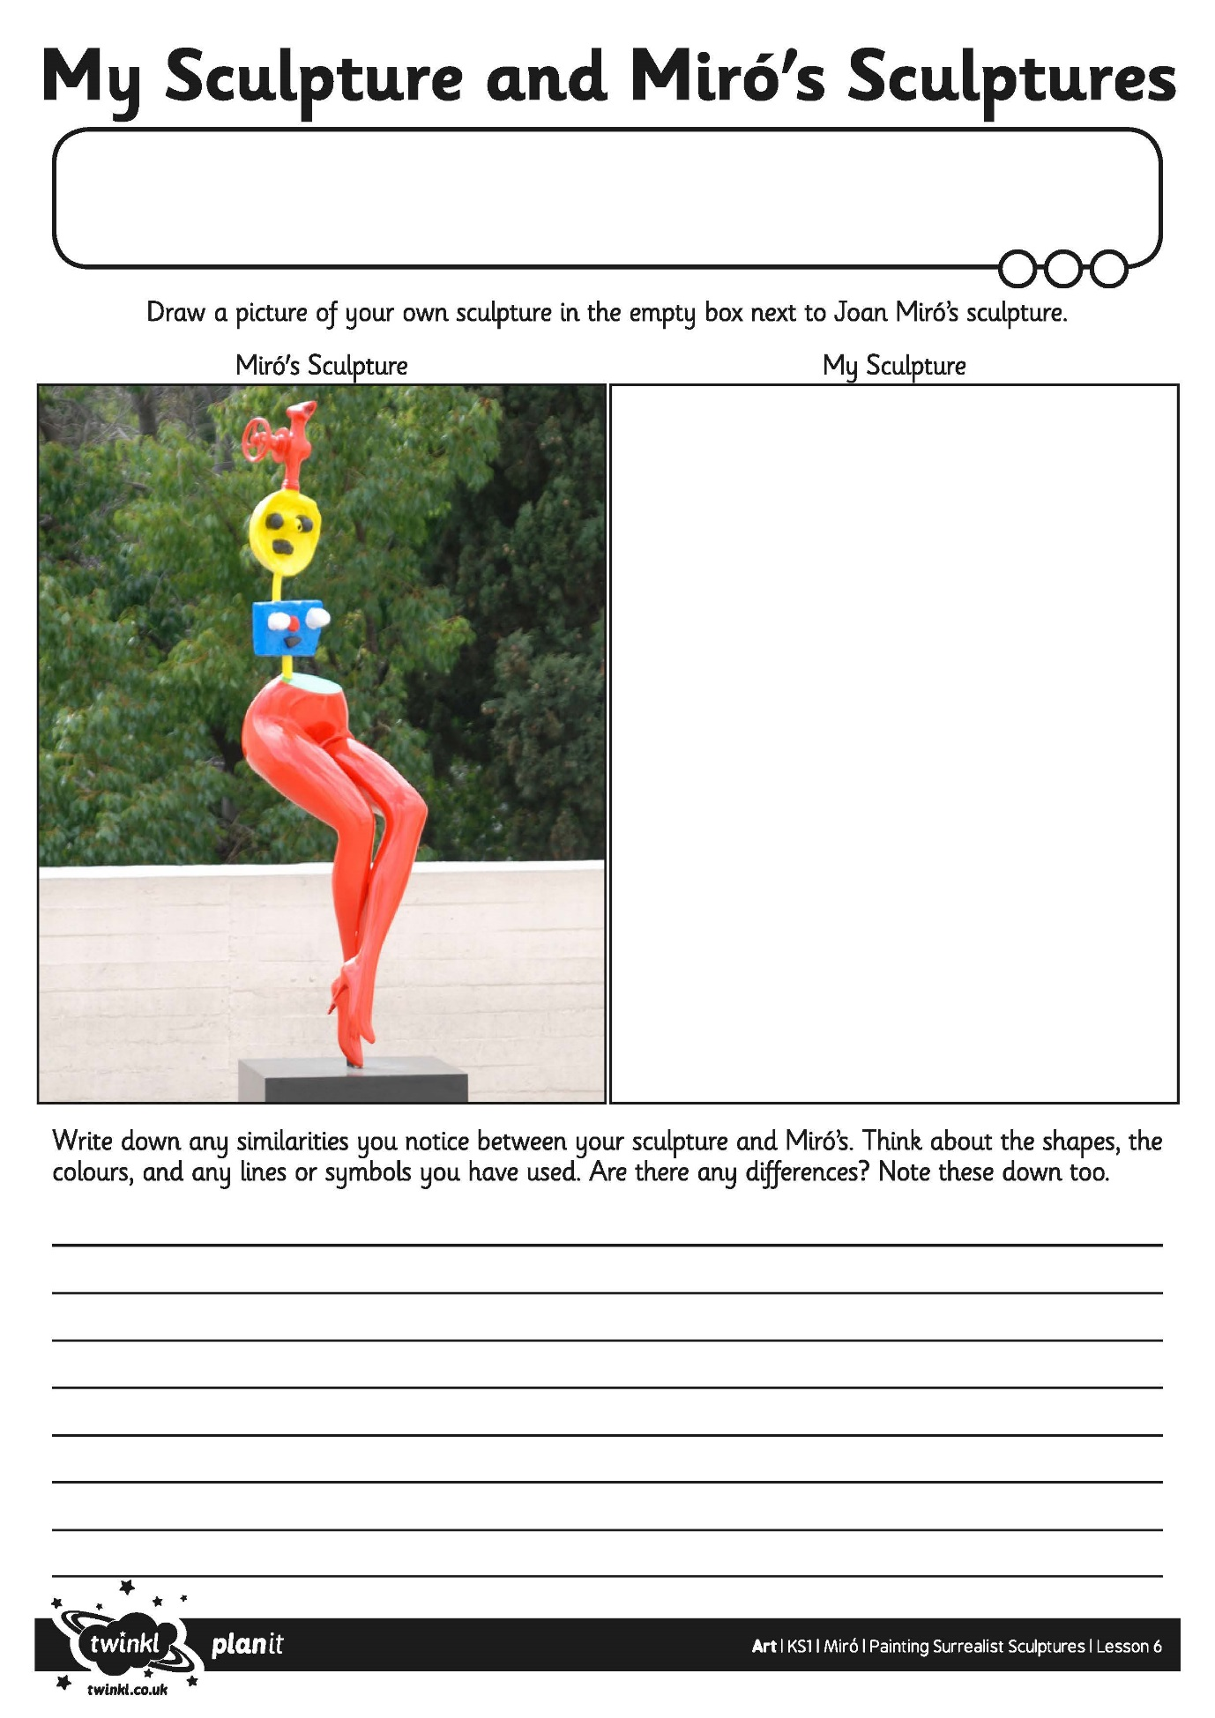
I can identify some similarities and differences between my own work and Miró’s.
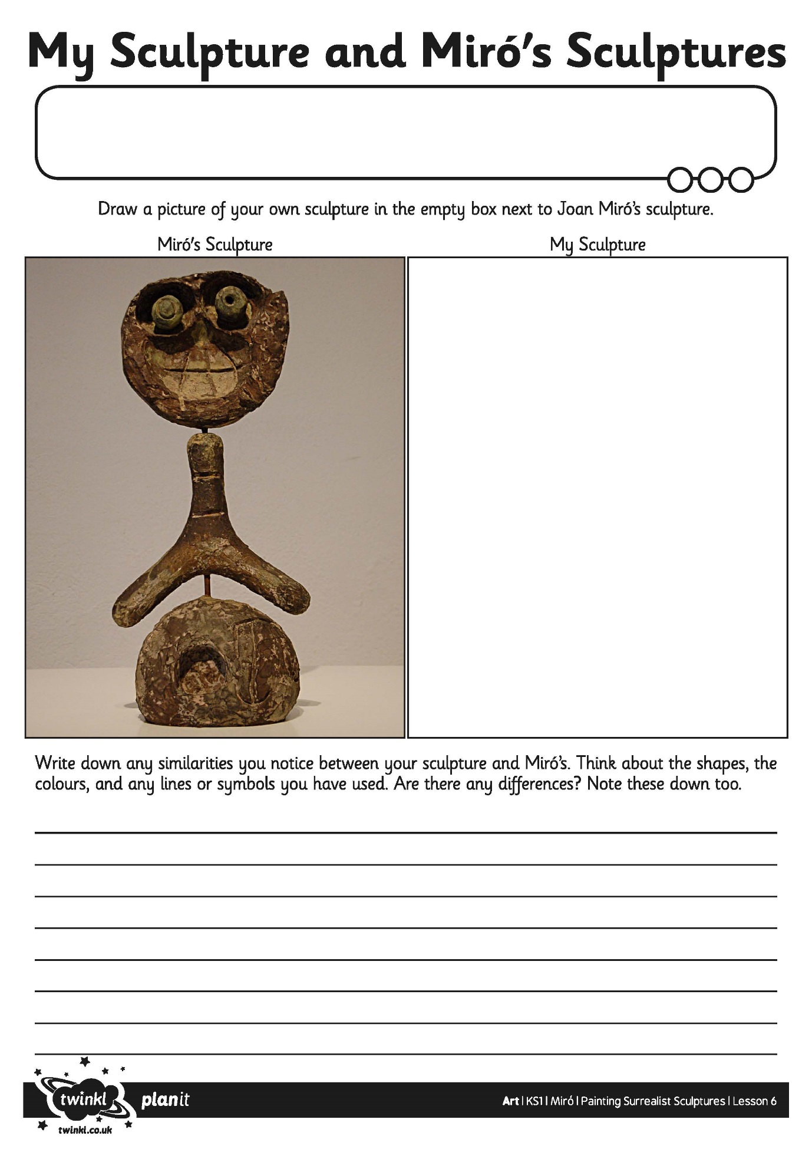
I can identify some similarities and differences between my own work and Miró’s.
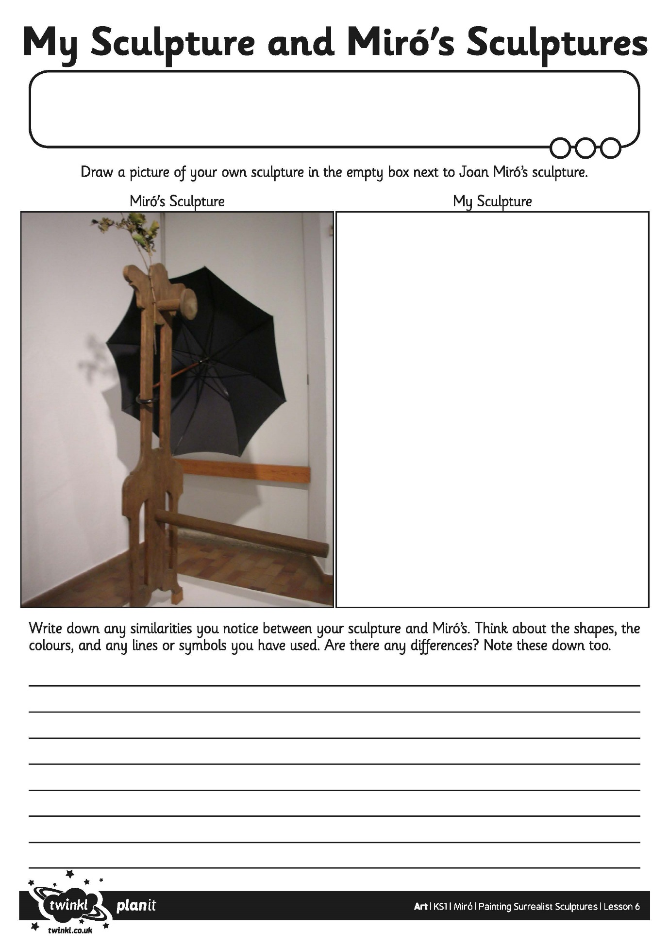
I can identify some similarities and differences between my own work and Miró’s.

