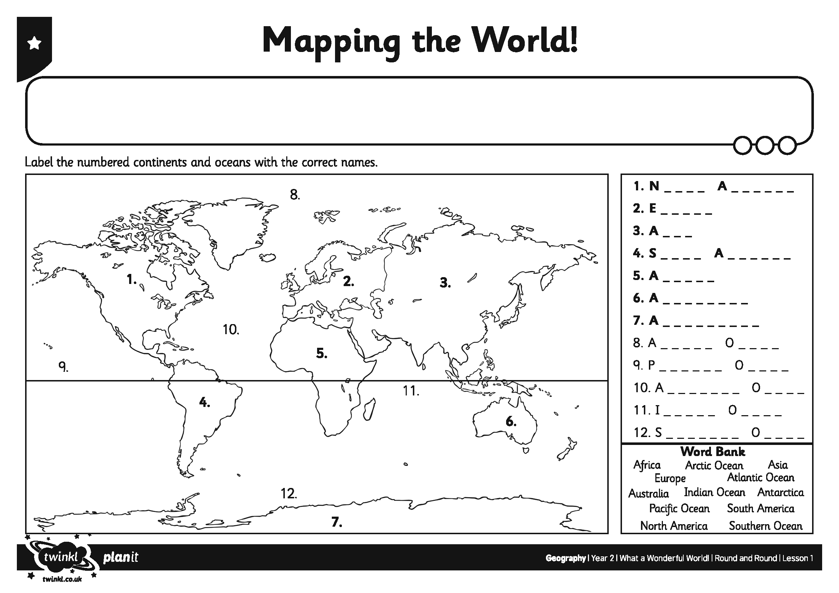
I can name and locate the continents and oceans of the world.

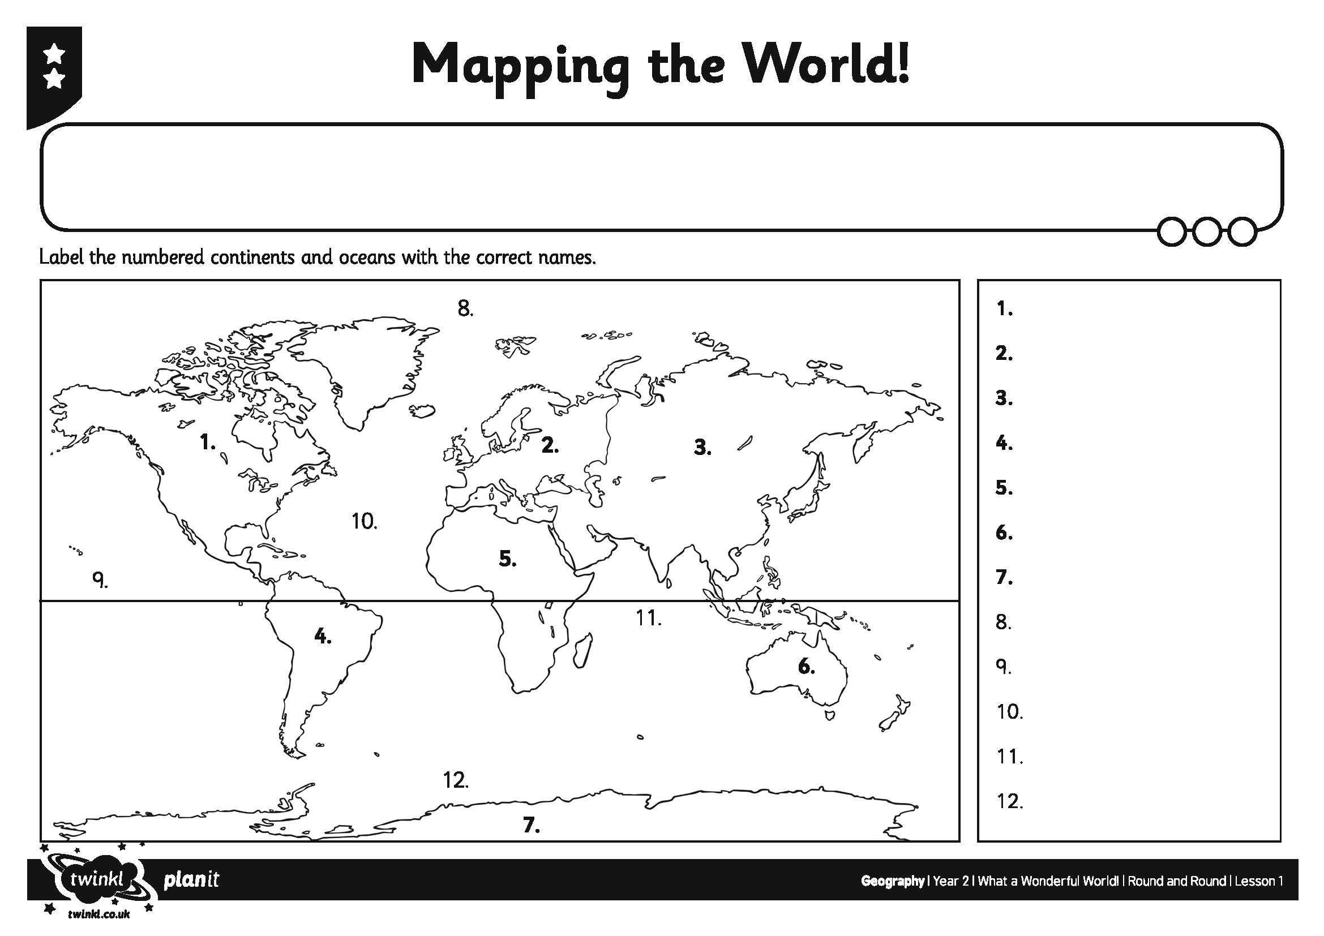
I can name and locate the continents and oceans of the world.

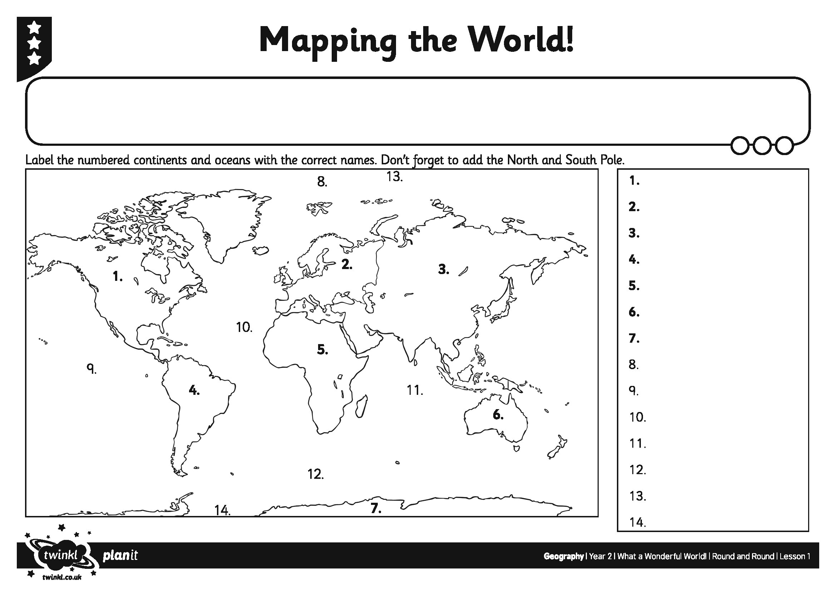
I can name and locate the continents and oceans of the world.

