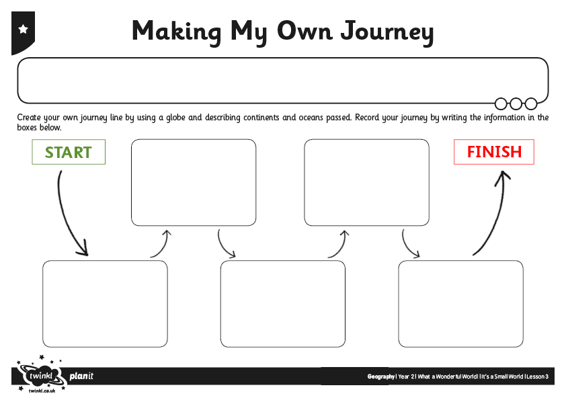
I can understand how a journey can be made around the world.

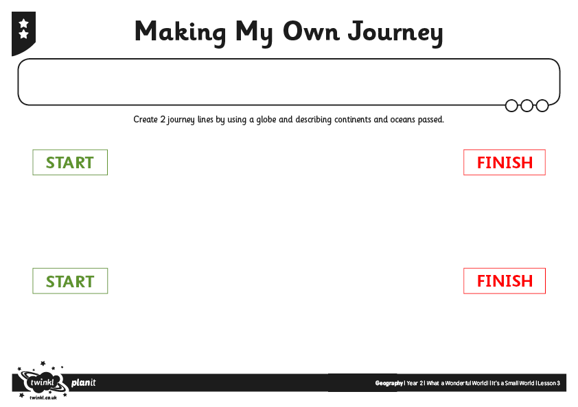
I can understand how a journey can be made around the world.

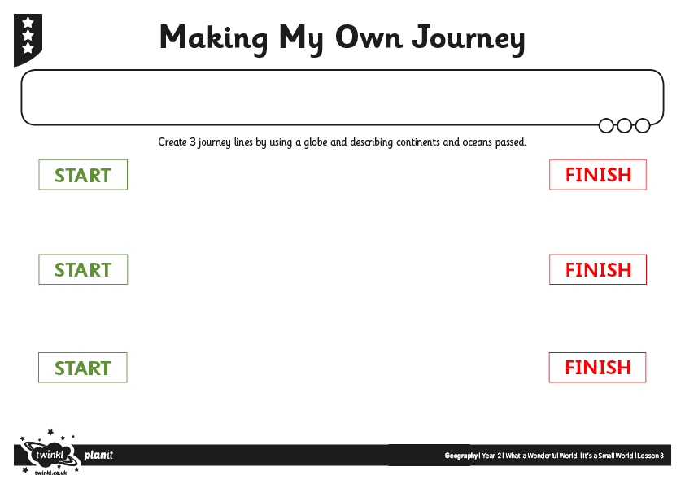

I can understand how a journey can be made around the world.

