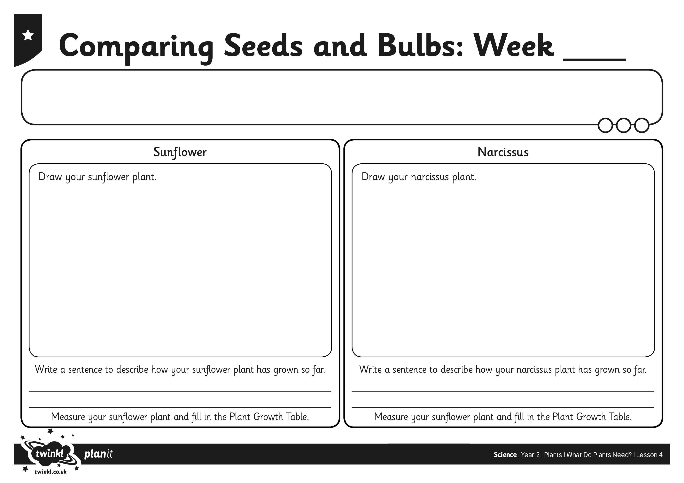
I can observe and describe the growth of different plants.
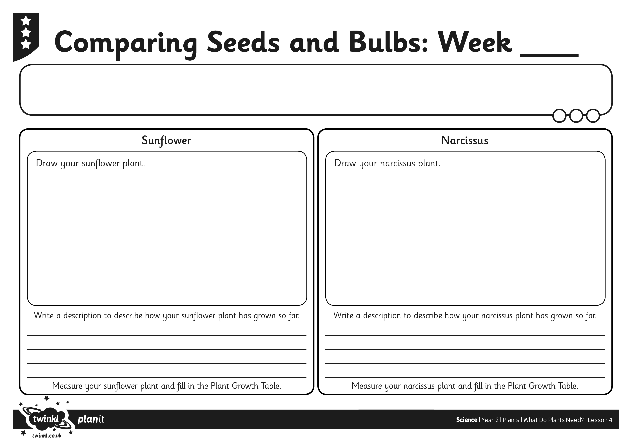
I can observe and describe the growth of different plants.

