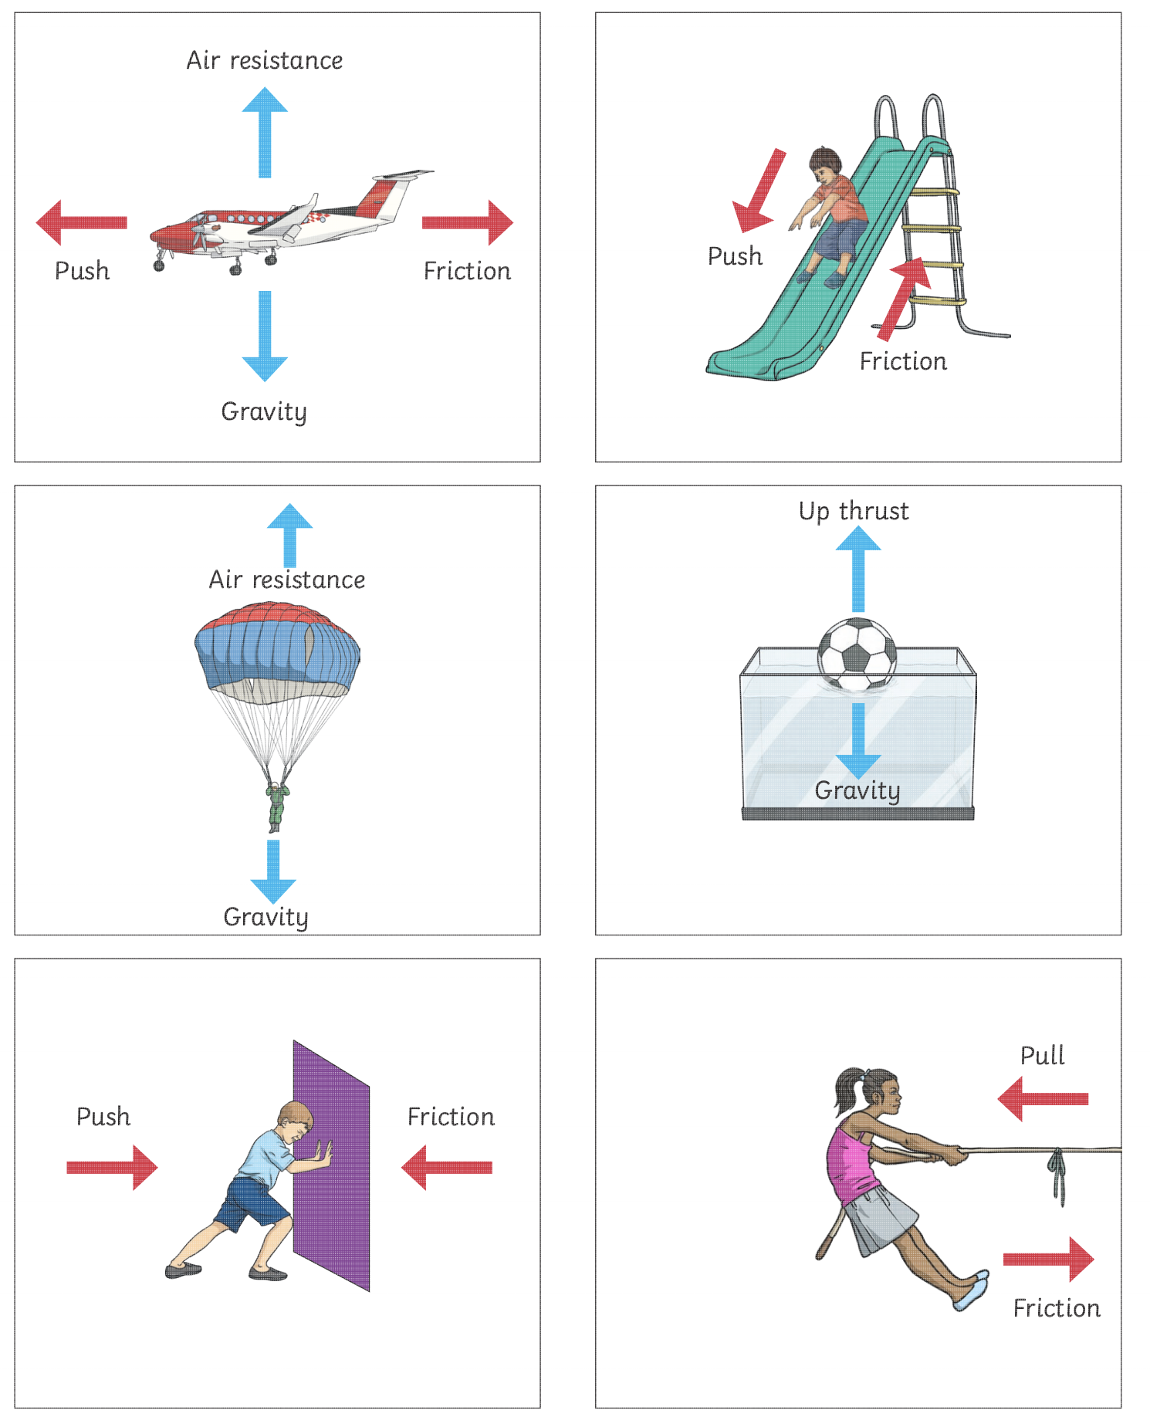

**Activity 2 –label the arrows with the correct forces**

**(air resistance, gravity, friction, upthrust, push and pull)**