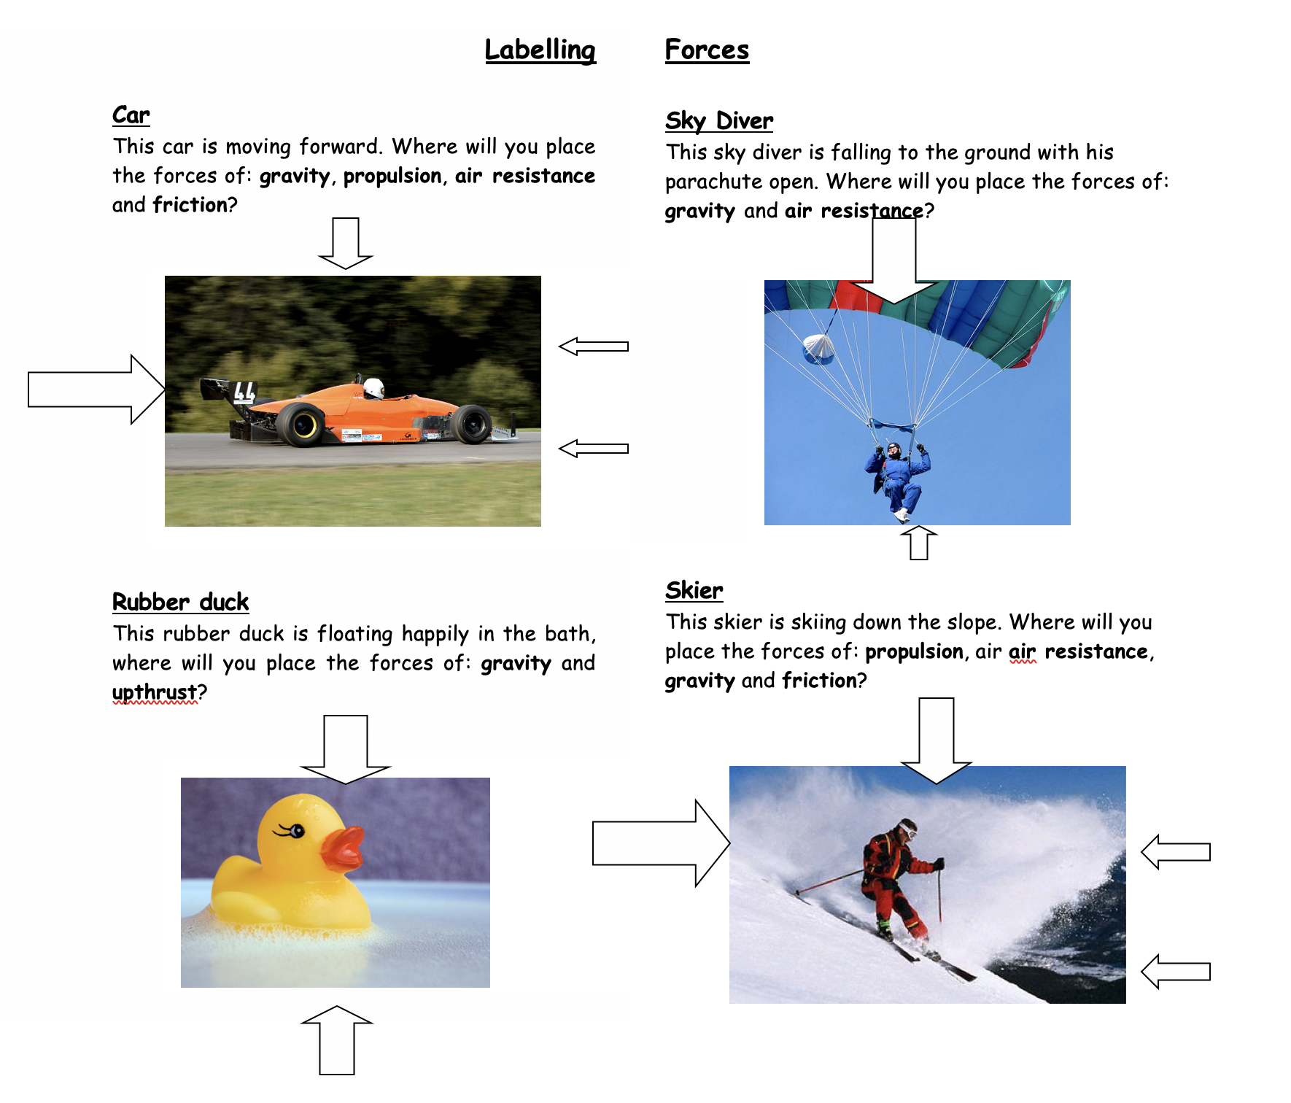

**Activity 1 – use the forces in the descriptions to label the arrows**