Name:
Please tick as many answers as appropriate
Which of these are microbes? |  |  | The smallest microbe is a:
Bacteria |  |  | Bacterium
Virus |  |  | Virus
Antibiotic |  |  | Fungus
Fungi |  |  | They are all the same size

Microbes are found: |  |  | Which foods or drinks are produced through the growth of microbes?
In the air |  |  | Cheese
On our hands |  |  | Bread
On surfaces |  |  | Yoghurt
Everywhere |  |  | Fizzy drinks

Microbes: |  |  | Which of these microbes causes the common cold?
Are all bad/harmful |  |  | Bacteria
Are all useful |  |  | Virus
Can be harmful or useful |  |  | Fungi
Have no effect on the human body

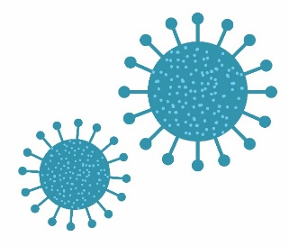

Which of these are shapes of microbes? |  |  | What is another word for a harmful microbe?
Rod |  |  | Infectious
Balls |  |  | Antibiotic
Spirals |  |  | Pathogen
 |  |  | Flora
