Giacometti Week Two Art Work

For this week’s extra art activity, you will need the foil man you made last week when you were exploring Giacometti. If you didn’t make him you will have to make him first.

I would like you to bend your foil man into a position, check where the correct bends are by posing in this position first, so you are aware of how to pose him. Then either put a torch behind him or the sunlight to cast a shadow of the figure. Draw around the shadow and shade in dark, you can then move the position and repeat. You should create different shadows. I look forward to seeing how you do.

Here are some examples to inspire you:

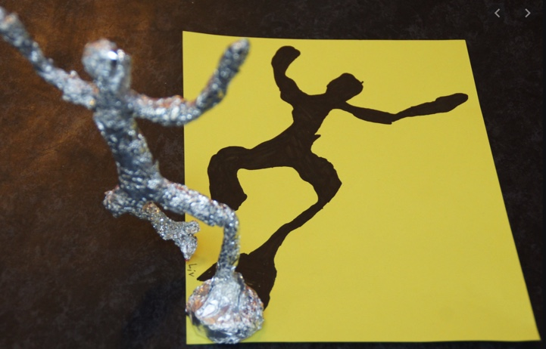
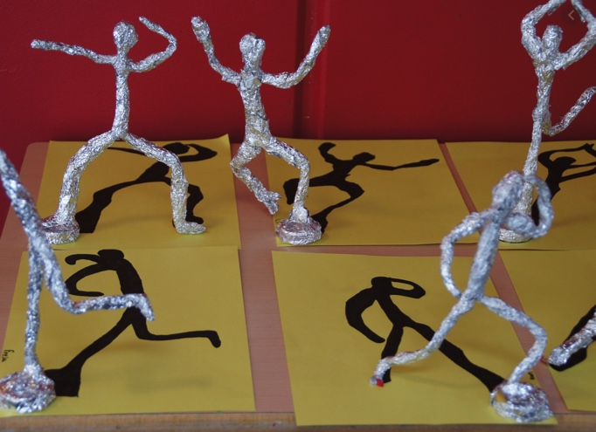
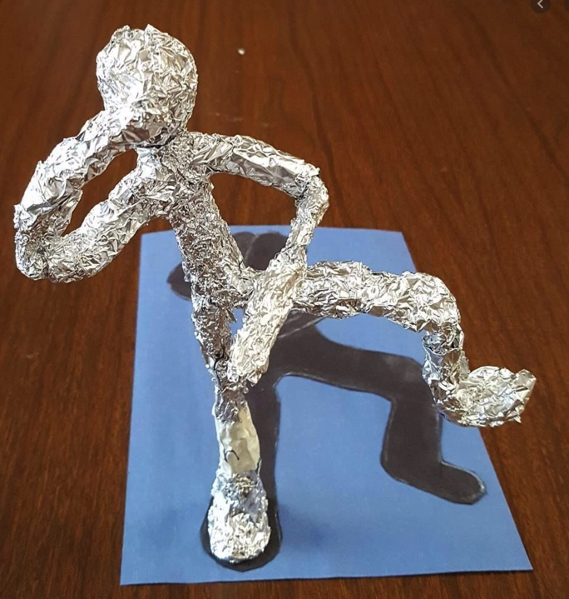
Please send through your examples to my email – I saw some fantastic foil men last week – well done!

