
Newsletter
Date: 3rd July 2017
Tel. 01625 383055
www.mobberley.cheshire.sch.uk

Dear Parent/Carer,



Golden Certificates for the week ending 30/06/2017
Reception ~ Emily Mottershead
Year 1 ~ Phoebe Zephir
Year 2 ~ Katie Campbell
Year 3 ~ Ben Ashworth
Year 4 ~ James Jackson
Year 5 ~ Maya McNiven
Year 6 ~ Oscar Fogg
All these pupils gave 100% in their studies last week.



Good to be Green week ending 30/06/2017
Reception ~ Sienna White
Year 1 ~ Jalen Johnson
Year 2 ~ Briley Hargreaves
Year 3 ~ Callum Hirst
Year 4 ~ Theo Hoskins
Year 5 ~ Emily Cran-Crombie
Year 6 ~ Jessica Evison-
Williams
Well done to all children who keep the Golden Rules all week and whose names are entered in the class raffle.


Winning House
Wilfrid with 244 House Points, Green 242, Griffin 236 and Mallory 231.
Well done to Wilfrid!

.


Attendance week ending 30/06/2017
Reception ~ 99.00%
Year 1 ~ 97.33%
Year 2 ~ 93.85%
Year 3 ~ 98.10%
Year 4 ~ 97.69%
Year 5 ~ 95.50%
Year 6 ~ 97.00%
Well done to Reception and Year Three, our Key Stage 1 and 2 class attendance winners.



Lunchtime Golden Table
The winners for last week were:
Reception ~ Amelia Price
Year 1 ~ Macey Valentine
Year 2 ~ Katie Campbell
Year 3 ~ Callum Hirst
Year 4 ~ Ellen Grassby
Year 5 ~ Emily Cran-Crombie
Year 6 ~ Beatrice Moore


VIP’s this week
Our VIP’s this week wearing the red sweatshirts will be:
Reception ~ Freddie Howarth
Year 1 ~ Ben Sykes
Year 2 ~ Oliver Valentine
Year 3 ~ Iona Anderton
Year 4 ~ Alex Done
Year 5 ~ Bailey Johnson
Year 6 ~ Daniel Thompson

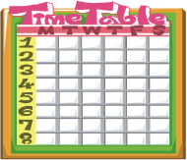

Times Table Champions
Times Table Certificates have been awarded to:
~ Freddie Knight (x4)
~ Theo Hoskins (x5)


Summer Fair Thank You
Sincere thanks to everyone who contributed in any capacity to ensure our Summer Fair was a successful event. The sun shine, donations of prizes that came pouring in last week and parents / visitors were entertained by our maypole and country dancing. Pupils and staff ran their Rainbow Stalls, staff from Lower Moss Wood shared their knowledge about birds of prey, Mobberley football coaches / players drummed up support for the local boys’ team and children tried their forest skills. Face painting was back by pupil demand and the Bottle Bola by parent / visitor demand. The food and catering was superb. Congratulations to Aimee Martin-Bird (Chairperson PTA), along with her committee, who organised a superb social / fundraising event for our school. I am very appreciative for the outstanding support from all families for school events.

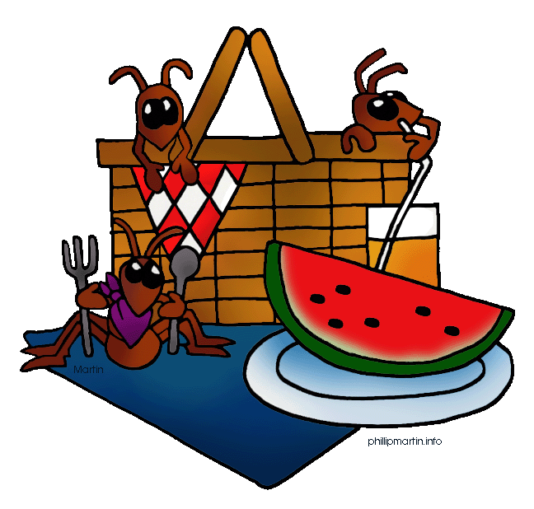
Year 6 Diocesan Leavers Service
This takes place at Astbury St. Mary’s Church near Congleton on Thursday this week followed by a picnic lunch at Astbury Mere (red note in your child’s bag last Friday).
This is not for our parents to attend. We have our own Leavers Service on the last day of term (9:30am).

PTO

Class Swap
Children will spend a morning in their new classes for September with their new class teacher on Wednesday or Thursday of this week. A note will be coming home to parents.
Miss Rainbow, who is joining the teaching staff in September, will be in school on Wednesday. Please come and say hello to her at the end of the day.
The usual ‘Greet the Teacher’ meeting will be held in the second week of September and this will be the opportunity for you to meet your child’s class teacher informally. We are very fortunate to be able to afford an extra teacher so that all pupils will be taught in single age classes.



Junior Summer Production
The show is ‘School Daze’ and this will take place in the Victory Hall on the evening of Wednesday 19th July (6:30pm). There will be a dress rehearsal and grandparents and toddlers are asked to attend this performance. The evening performance is restricted to adults only (2 tickets per family). No preschool children at the evening performance please. A detailed note with your ticket allocation will come out to Years 4-6 this week.


Clothing Request
Do you have any of the following items (in good condition, clean and washed) that you can donate to school before the end of term, in preparation for next year:
~ Old (men’s) shirts that can be used as Art Overalls.
~ Any spare PE kit.
~ Childrens’ underwear suitable for Infant age (4-7).

MOPS NEWS

LAST WEEK AT MOPS DIDN'T GO TO PLAN DUE TO THE WEATHER. OUR FUNDRAISING WILL BE PITCHED AGAIN THIS WEEK AND WE HOPE TO RAISE A LITTLE MORE FOR THE GUIDE DOGS. REMEMBER THAT THE FIRST PRIZE IS TWO FREE SESSIONS AT THE AFTER SCHOOL CLUB AND SECOND PRIZE IS ONE FREE PLACE.

WE HAVE NO ADULT LED CRAFT THIS WEEK.

ON TUESDAY WE ARE HAVING STRAWBERRIES AND ICE CREAM 🍦 FOLLOWED BY A MINI WIMBLEDON TENNIS 🎾 TOURNAMENT

THE FOLLOWING WEEK .......ON TUESDAY 11th JULY IS OUR END OF TERM EVENT FOR THE CHILDREN. WE HAVE AN OUTSIDE COMPANY SHOWING THE CHILDREN HOW TO MAKE CHOCOLATE PIZZAS AND LOLLIES. THIS SHOULD BE GOOD FUN PLUS THE CHILDREN GET TO TAKE THEIR "GOODIES" HOME.

AT THIS TIME OF YEAR ALL THE CHILDREN REALLY WANT TO DO IS PLAY OUTSIDE, SO WE ARE WINDING DOWN OUR ADULT LED CRAFTS TO ENABLE US TO SPEND MORE TIME OUTSIDE. HOWEVER, WE SHALL STILL HAVE OUR ART AND CRAFTS TABLES FOR THE CHILDREN TO USE THEIR OWN IMAGINATION IN WHAT THEY CREATE.

IT WOULD HELP US GREATLY IF CHILDREN CURRENTLY REGISTERED AT MOPS ARE GOING TO ALTER THEIR DAYS IN SEPTEMBER.......WOULD LET US KNOW BEFORE THE END OF THE CURRENT SCHOOL YEAR. THANK YOU.

FOR FURTHER INFORMATION ABOUT MOPS PLEASE RING 0775 9573603.

WE ARE STILL LOOKING FOR A THIRD MEMBER OF STAFF FOR OUR AFTER SCHOOL CLUB TO WORK MONDAY, TUESDAY AND WEDNESDAYS FROM SEPTEMBER.

IDEALLY THIS PERSON WILL HAVE A RELEVANT CHILDCARE QUALIFICATION OR EXPERIENCE IN WORKING WITH CHILDREN. HOWEVER WE WOULD CONSIDER AN APPLICANT WHO IS PASSIONATE ABOUT CHILDREN AND WILLING TO LEARN WHILST WORKING AT MOPS.

PLEASE RING 0775 9563603

.

